Sweet Dreams (or Sweet Girly Dreams)
Originally “A Pretty Girl” this is Number 46 for John
By Maryanne Peters

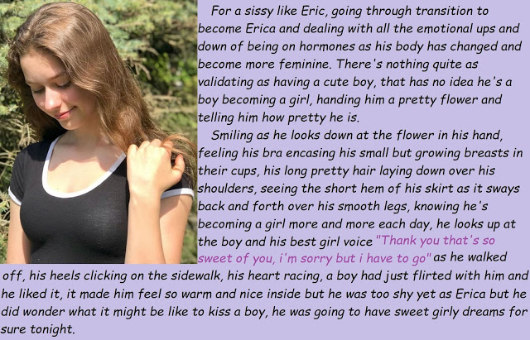

La di da di da! It is just so wonderful being a girl. Who would ever want to be anything else?

Maybe I did once. Think about being a boy, I mean. But everything has changed now. At last John has stepped forward and given me the sign I have been praying for.

I know that he has been admiring me years. He lives next door you see. I know that he talked to my mother about me. She said: “You have a patron in John. He wants the best for you, just as I do.”

I am small, you see. Small and slight. Not sickly, but not robust either.

Mom said: “You will never be a big strong man so we need to prepare you for a future where you can use the assets you have.” She said that soft shiny hair and soft translucent skin were wasted on a boy.”

John supplied the vitamin tablets to build me up. They did not make me stronger but they certainly made me prettier. And bigger in places where he wants me to be big. And smaller in places where he wants me to be small. And soft all over, just the way he likes me.

Mom always say: “Do what john wants you to do. He cares for you. He only wants the best for you.”

I might have doubted it at the start, but I don’t doubt it now. John is my special friend. I knew it from the first moment I saw it in his eyes. He wants me. He wants me like crazy. Is there any better feeling than that? Being wanted like crazy I mean.

I could say no. I could watch him squirm if I did. But why would I do that? I like John. I may have thought it was a bit weird at the start, but now I understand that he is acting on his emotions, not some strange plan.

I am emotional too. I haven’t always been, but I am now. The tears used to scare me, but now I understand. I’m sensitive. I’m sensitive all over. It’s wonderful. That is what being a girl is like.

But I know what John expects. I know what a girl like me has to do to give him that. A girl has to be able to take a man inside her. I am expecting John to be big, so I have prepared myself. But I still want to be able to squeeze him when he is at full length. I have been practising that too. There is a muscle there, you know … or something. Whatever.

I have been dreaming about this for so long. When I imagine it is him rather than the plastic, I find myself oozing, and sometimes shooting out a little bit. That has to be a good thing.

I have his flower in a vase on my bedside table. I want his to see it there when he comes around tomorrow night. It will be my sign that I am ready. There is his flower, now deflower me, John. Isn’t that a wonderful word – deflower me. Hmmm.

Tonight I am going to dream about it. I am going to have to wear panties with a pad in them under my nightie tonight, in case I dribble. Thinking about John and what he is going to do to me in just 24 hours, makes me wet.

The End

Have Some Fun
For John Number 47
By Maryanne Peters

You need to get one thing straight: I am not gay. If you want to confirm that, just take one look at Heidi, my girlfriend. Then you know how much I love women.

Honestly, the idea of cuddling up to something hard-muscled and hairy is disgusting to me. I play ball with the guys. I would not even look at them in the showers. Guys are guys. I’m a guy. I am not into guys, OK?

There is no way that Heidi is a guy. I don’t think that she ever was one, even when she was Hunter, the school sissy. I could see the girl in her. That is what sissies are – girls fighting to escape their male bodies. I knew that from the start. It is hard to stand up for a sissy, but I did. When you are the head jock, the quarterback and indispensable, you can get away with it.

I always said: “Leave the kid alone. It’s tough for people like him”.

So when Heidi finally came out as Heidi, I took her on a date. The principal said to the school: “Special congratulations are due to our team captain Brad Hopkins in taking the lead again, with our first transgender student. You should all follow his example of tolerance and understanding.”

That was nice, but what I really wanted was to fuck that sissy’s brains out.

She is a girl, I tell you. Ok so she is missing a woman’s hole, but what she has does me nicely. There is something about a vagina that I find a little disgusting, what the blood and the fishy smells and stuff like that. A boi pussy can smell sweet as a cupcake if Heidi prepares properly, as she always does. And Man, is she tight!

I don’t mind that little thing flopping around while I am deep in her. Its always flopping now, because has had her nuts taken out. Sometimes I pull it a bit, just to make her squeal, but the truth is she gets more feeling out or her tits these days, now they are grown big enough to shake around as I pound away.

I love her tits. Like I said: I am not gay.

It is just that when she told me that she was going to go the whole way and get a vagina, I felt that it was wrong somehow. I mean, the little cock makes her special. It makes her mine. It is like a warning to other guys to keep their hands off my girl.

I mean, a man-made pussy does sound appealing, especially when she offers to have it customed made to fit me, but somehow … I don’t know what.

Anyway, until then, or maybe even after, I want to have some fun.

The End

The New Golden Boy
Story for John Number 48
By Maryanne Peters

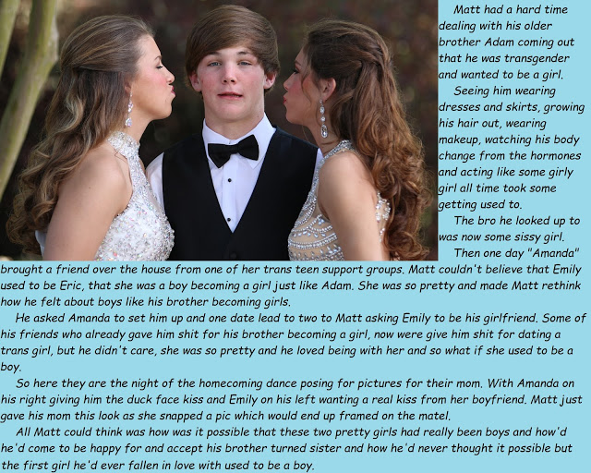

I am not saying that I am transphobic or anything like that. I really did not care about the whole transgender thing. It did not apply to me, until suddenly it did.

To me my older brother Adam was like a god. He seemed good at anything he turned his hand to. Not just the application of hard work, although he did that – he had talent, and I didn’t. It seemed as if I was always be the lesser brother. Now I am the only brother.

I never thought that I would be as robust as him, but now that the hormones have softened his body, I am bigger and stronger. There is no sport for him now. He is not interested in that anymore. “She” is now only interested in clothes and hairstyles.

It was all a huge disappointment for Dad. That was the most lasting thing, once he was over the shock and disbelief. Adam told him that daughters always love their daddies more, and after a while Dad came to understand that was true of Amanda.

I said that Adam was good at anything he did, and the same was true of becoming a girl. Application and the innate talent, as always. He was not just a female version of himself, he ended up being one of the prettiest girls in school.

She (Amanda) said that she had help. There was a trans teen support group in our neighborhood. It seemed as if she quickly took a leadership role there, being such a positive example.

She ended up making Dad proud of her for being the best young transwoman. Imagine that? I was doing my best to do everything that Adam should be doing, and he was talking about how wonderful she was at doing her hair.

I might have been bitter, but it was Amanda who introduced me to Emily, and that makes up for everything.

I thought she was joking when she introduced her as being: “A trans-girl like me”. It just did not seem possible. She was just so pretty. Even Amanda did not know that Eric, as she was before, had been in my class two years before. She had been taken out of school for being teased. Not by me, but by other guys. Eric never came back.

After months of trying to “cure” her, her parents relented and allowed her to transition. She even has an operation booked that will get rid of the last bit of Eric. I know all about it now. She wants me to be the first person to see it. Maybe I could be the first person to use it, for what it will be intended for. I hope so.

Amanda wants the same thing, and she is old enough to have it done now. Dad is uncertain. He has accepted her completely, but still surgery that will see that part of his golden boy thrown in the trash is hard for him to handle. He says it will be up to me to carry forward the family name.

But the only problem with that is that I only want one woman and she cannot bear children. How can I explain this to Dad?

The End

When do you Know?
Inspired by a cap by Becky
For John Number 49
By Maryanne Peters

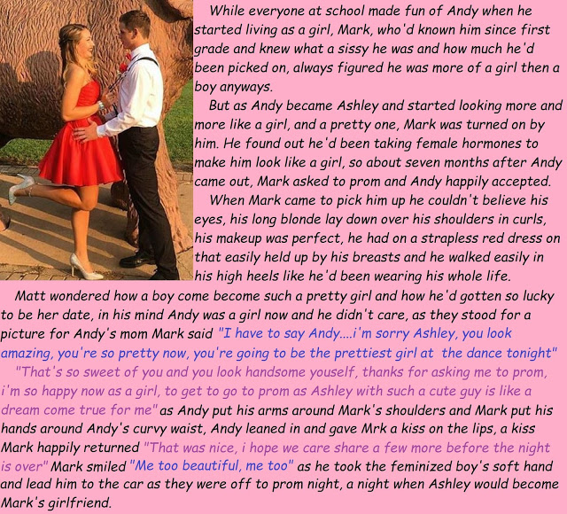

Let me tell you all about it! Let me tell you about Mark! Let me tell you about that night!

I had known Mark for years. I won’t say that he defended me when I came out as transgender, but he certainly was not among all those who were mean to me. I guess that maybe he had always known that I was different. That made him different. More accepting, maybe?

More than that – don’t think a girl doesn’t notice, even when that girl has only just started being a girl. I could see the change in the way he looked at me. Even if he was hiding it, and trying to look away, I could see. It made all the effort I was putting in, all the drugs I was taking, worthwhile – to see the effect I had on a guy. It was thrilling!

So, when he asked me to prom I was not so surprised. But wow, was I pleased! I had to pull out all stops with the hair extensions and the red dress, and the heels. There was no way I was going to let a guy down when he chose to treat me as a girl. I was going to be more girl than anybody else at the dance.

He gave me a red rose. He told me that I was going to be the prettiest girl at the dance. Although it does not get hard, sometimes I get a little jizz in my panties if I get really excited. Lucky I was wearing a panty-shield when he kissed me. Luckily I had a spare in my clutch-bag. A girl has to be prepared.

It was my first kiss, and he promised me more.

And more than just kisses. After the prom we went to his older brother’s apartment where there was a spare room. I knew what he wanted. I wanted it to. I would have just blown him, but he was ready to enjoy my whole body, and that meant so much to me. I could hide the bit I was ashamed of, but by that point I had him so excited he hardly even noticed it jingling around as he pounded me. He might have noticed when it spat a little something on to my girlish belly, but I think he was too busy watching my face in ecstasy and hearing my happy little squeal.

Don’t think I did not go unprepared. I had been preparing for weeks to make myself open to receive all of him – assuming he was manly, of course. But still making sure that I was tight, and that I could squeeze him in that special way. I had been preparing in the in the hope that Mark would be the one. I think that I have always known that he would be.

The End

His Sissy Girlfriend
Inspired by a cap by Becky
For John Number 50
By Maryanne Peters

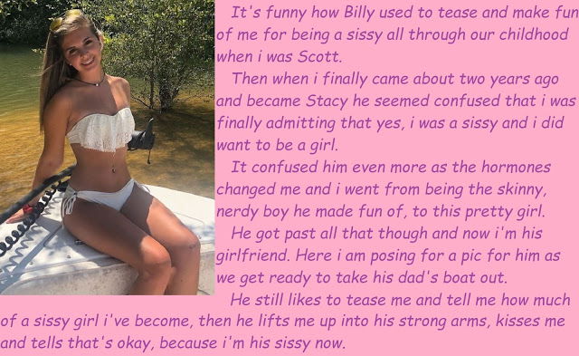

If loving Stacy makes me gay, the so be it. Ain’t it funny how life turns out. I used to say that little Scotty was the biggest simpering fag in the whole school. I used to tell him: “Stop pretending you are a guy. You should start wearing dresses.”

And then one day he sidles up to me and says: “Billy, you know, you are right. It is just too hard pretending to be what I am not. You call me a sissy, and I guess that’s what I am. You tell me I should start wearing dresses, so I guess I might just do that,”

The next day, he turns up to school in a skirt. Says it’s a “kilt” or some such, and that is what Scots people wear, and he is a Scott, so who is gonna say no? The teachers have to agree that it is traditional dress – the kilt and the full baggy shirt with embroidery in the front.

Scotty gets to wear a skirt to school because of the diversity and “expression of ethnicity” rules. But Hell, I am not so sure Scotty is even Scottish.

But then Scott has other kilts and they are short. Scotty likes to look at me when he is wearing them, and when nobody is looking he uses a finger to lift the hem so I can see his shaved thigh.

“Is this the kind of outfit you want me to wear, Billy?” That guy.
And Scotty starts to grow his hair long – really long. And it seems that those big shirts are hiding something underneath. Yep, Scotty is growing a pair of tits.

“But it was your idea, Billy,” he says. “I have to say that there is something about you that just makes me want to do anything you say. I just like making you happy.”

I said something like: “If you want to make me happy then get lost”. But Scotty just flounces off with a big smile on her face. And everyone looks at me, like: “What is going on here”.

Nothing. Nothing going on. At least not at the start. But then I find I can’t get the thought of Scotty out of my mind. Except in my mind he ain’t Scotty at all. He is a girl with Scotty’s face. I have dreams like I am chasing her though a forest, or lying with her beside the lake, or fucking her in the tall grass, and she has a small pussy and a big smile.

That is not gay, is it? Not if I am dreaming of a woman?

So, I corner him on the way home, pin him to a tree near our place. I say: “What the fuck are you?”

“I am a sissy, Billy. Remember? I am your sissy. I want to be a girl, if that is what you want. I want to be your sissy.”

I was mad, or I thought I was. There was something in me that wanted to punch him in the face right then and there. But there was another part of me too, and that had already decided what it was gonna do. Scott saw it too. He reached down and touched me through my pants.

“I am not Scotty anymore. For you I am Stacy and I always will be”. That is what she said, because from that point that is what she was.

Look at her now. Look at that hair and that little white bikini with the little flouncy top covering her luscious titties. Tell me what that is – is that a sissy or a girl? Well, it sure ain’t a boy, that’s for sure. But if it is, I don’t mind being gay as long as Stacy is my sissy girlfriend.

The End

© Maryanne Peters 2020

