Finally Getting Home
A Short Story
By Maryanne Peters

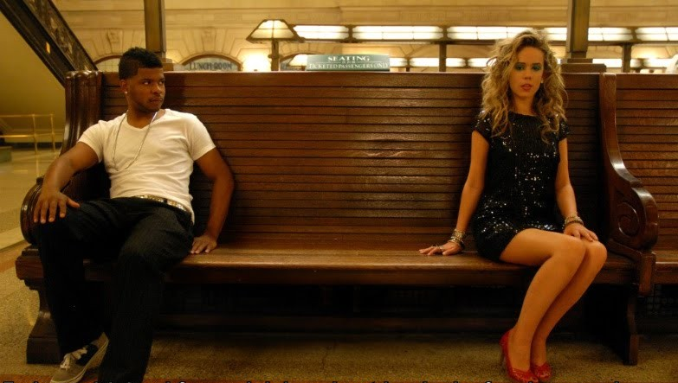

Part 1: The Platform

She sat at the other end of the bench, away from Sunny. She was white, and she was pretty, and Sunny was not surprised or annoyed. There was just something about her that he could not work out. She was dressed like she had just stepped out of a party. She was wearing glittery navy blue dress, very short, and red heels, very high. Her hair was blond and in soft curls, her makeup looked ready for the evening that was now upon them. She had bangles on her wrists, but she carried no bag.

Sunny had no reason to carry a bag. He had a wallet in his hip pocket and money on his card. He was ready to go into the city. He had his ticket in his side pocket. Where was hers.

“Excuse me Miss,” he said. “This seat is for ticketed passengers. Do you have a ticket?” It was just to strike up conversation.

She looked across at him with a worried expression on her face. He could see that she wanted to say something, but she simply kept her mouth shut. She turned away again.

“I’m sorry Miss. You must be travelling with somebody else. Forgive me the intrusion, but I can’t help but notice that you are not holding a purse.”

He could see her biting her lip, as if about to burst into tears, or stop herself from that or something else.

“If I can help you Miss, you only need to ask” It was a genuine offer. Sunny was a genuine guy.

She spoke, but it was the voice that surprised him. “I don’t have a ticket. I don’t have any money. I just want to get home.”

It was a man’s voice, perhaps a little shrill from the obvious distress, but a man.

“Whoa!” said Sunny, almost involuntarily. “I thought I was just looking at a woman too gorgeous to be sitting alone, but from the sound of your voice, maybe I’m mistaken. Don’t tell me you’re a dude?”

“Ok. I’m not used to this. I can’t hide my voice. But I am not a tranny. I am just a regular guy. I have a girlfriend. She did this to me.”

“Wow! I got to say it Man, you make one hell of a hot chick! Not every tranny can pull it off, but you … all I have to is … Wow!”

“This is her idea of a joke. Her and her beauty school girlfriends. Put me to sleep, do a number on me, then take me to the outers and dump me at the rail station.”

“Well maybe she did you a favor,” said Sunny. “I don’t know what you look like as a guy, but that would be a waste. The world needs more beautiful women. Seriously you’re a knockout.”

“I know you mean well, Buddy. Thanks for the compliments. I am sure that she would love to receive them. What you see is her work. Her and her pals. You can see, hair extensions and everything. Tits stuck on under this dress. I can’t just take this all off. I am in a real mess here.”

“That sounds like a problem. You have really great legs, if you don’t mind me saying.”

“At least she left me at the station. I figure that I can jump on the train and do my best from there.”

“I have a ticket. I can get you another. We have a while before the train leaves. We could ride together.”

“That would be great,” she said. Her pretty lips broke into a smile. “If you would do that, I would owe you big time.”

“The pleasure of your company would be overpayment in return,” said Sunny, with the easy charm that usually ensured that he got laid on every trip into the city. “That’s a hell of a dress you’re wearing.”

“I is my girlfriend’s. I bought it for her. She didn’t like it. She said it was slutty. She said I should wear it. Now she has put me in it.

“That girl sounds like a bitch. And a bitch without taste. Maybe she doesn’t have the body or the legs to get away with that look.”

“I think a woman should wear something feminine, don’t you?” she said, seeming to confirm that “the Bitch” preferred something else. “I mean dresses and nice shoes. Not pants all the time, and shapeless tops.”

“I’m with you on that. Like the clothes you are wearing now? It’s a great outfit. I would love a woman on my arm wearing that … looking as good as you do.”

“That’s my feeling.”

“Listen, I was just going into the city to spend some money, with nobody to do it with. It seems like I have what you don’t. So, like you say, clothes like that need to be worn. So why don’t you be that woman on my arm tonight. I don’t mean that I want you to do anything weird. Maybe just show up that girl of yours. We take a few selfies of you having fun is some classy places. You could send them to her and just say ‘hey, sometimes a great outfit makes for a great night out’.”

She smiled at him. “That does sound good. And you would have to see that I got home safely after all of that?”

“Of course. You will learn that I am a gentleman.”

“And nothing weird?”

“A gentleman,” he repeated. “And tonight, for the first and perhaps that only time, you will be a lady.”

“I’ll need to buy you a shirt,” she said. “But I will have to borrow he money from you.”

Part 2: The Apartment

She unlocked the door to her apartment and they both went inside.

“I don’t want you to think that I am the kind of girl who takes a guy home on her first date,” she said in the high voice that she had developed with his help on the train, and which she had been using all night, so as not to be caught out. “It is just so that I can get you some money. I really can’t accept that you ‘a gentlemen pays’ line. I have some cash tucked away, and I want you to take it, Sunny.”

“Darling Vanessa,” he said, using the name he had given her, and she had accepted. “I won’t take it. You might have to wrestle me to make me accept it.”

“Coffee or a nightcap?” she asked.

“Get some coffee on and lets start looking at those selfies,” he suggested. “We can decide which of them that we will be sending to your so-called girlfriend. And lets set up a new Instagram for the rest. How about #FunNess?”

“Why not?” said Ness. She felt buoyant despite their gruelling round of the local clubs. It had been a night like no other. She had been somebody new tonight. Somebody who never existed until today and so had seen the world afresh, and it was suddenly more exciting than it had ever been.

And Sunny had been beside her throughout. She watched him take her spot on the couch, and she approved.

She pulled out her phone and playfully plonked herself down on his lap so that the could both go through the images together.

Despite the dancing and the smells of four different clubs, her hair still smelt of the floral shampoo and he breathed it in.

“I have started that Instagram you suggested, and posted all tonight’s images to it,” she said. “Nobody will know that is me, but you need to go on and like me.”

“I do. I will.”

“But I will send some images to her. Just a few. Just to stick it to the Bitch”.

“Yes,” he said. He was distracted.

“Here is good one,” she said, wriggling herself into his body to get comfortable. “You and me with those other guys in the background looking to my butt.”

“That looks good,” he said. “Caption it - ‘what do these guys want?’ Keep scrolling.”

She typed a caption and pushed send. It was done. It would serve her right. How cruel to leave somebody like that? Imagine if it had been somebody else? Somebody other than Sunny. The might have been serious injury. Instead that this image said – ‘Look who’s having fun!’ Not her.

“I need to send her a couple more.” She flicked through. They were all good. “Are you nibbling my ear in this one?” she said, with fake indignation.

He pulled her hair back to repeat the action. She giggled and then stiffened a little.

“Sunny, are you having an erection?” said Ness.

“Babe, I am so hot for you right now,” Sunny said. “Of course I am having an erection, and it is just about ready to eat its way out of my pants.”

“I am not sure that this is a good idea,” she said. But she didn’t mean it. It was her idea and his too, and they were having it at the same time.

Her phone fell from her hand as his tongue entered her mouth. She was limp, but on heat. She was his.

He carried her to the bedroom and if to prove that she was small, and he was strong.

In rhythm with the sounds from the bedroom the phone whirred and came to life.

The screen read: “WTF. What are you doing?”

As it happened, they were making love.

The End

© Maryanne Peters 2021

The original “Getting Home” was only on the platform and was inspired by a Captioned Image by Tiffany. It drew comments like: ”Hope to see more to this story” and “May we can see more on what happens on her way home?”

