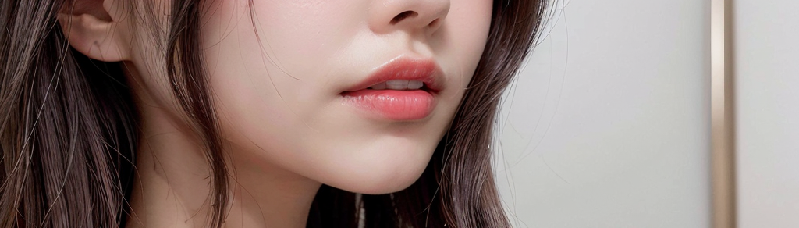
You don't need to be fluent or create well-crafted documents.
Just briefly describe your desired concept, attire, and situation, and if you send a few pictures, that will be enough. Your maids and I will fill in the rest with our creativity.
[Sample request message Copy and Send to DM or Email]

- Title : This is my request!

Hello Lote!
Below are My Requests!

- [Request content up to 4 lines]
Character : Kosa / Ash / Rurina / Sakura / Rin
-
-
-
-
- Images or Video referenced in the work-up to 3 URLs (Optional)
(Global Platform Only : Youtube, Instagram, Pixiv, DeviantArt, Twitter.)
-
-
-

If you want to send more reference materials : LimeDemian@gmail.com
(If you want to upload a high volume, we will send you an invitation link with file upload permission if you have a Mega ID.)

I sincerely and wholeheartedly thank you.
We will always work diligently for the Master.
Thank you.

