Today is too beautiful a day to waste at home alone and bored. So I decide to go to the mall. I tried calling my friends but apparently they all have school homework hahaha!! In my case, Twilight and Fluttershy have been very helpful to improve my grades, so fortunately I don't have pending school homework ... and all thanks to them!
You: The least I can do for them is buy them a gift or something for my appreciation for them.
Well, it was thought and it was done. However, just as I enter the mall, I see Fluttershy. She's standing in front of a women's clothing store…hmmm…should I go say hello?
You: hello Fluttershy! :D
Fluttershy: EEKK!! >///<
Oops, it seems that I scared her haha ​​XD.
You: I'm sorry! I scared you? It was not my intention
Fluttershy: oh no… dont worry hehe ^^
…
…
Awkward silence e-e
You: well… hehe, I'll let you do your thing, see ya!
I intend to leave when she stops me …
Fluttershy: wait! >///<
I can notice a strange expression on her…actually for some reason she is completely blushing! :O .. I must admit that it looks very cute! <3
Fluttershy: Do you have plans for today? I mean… we can do something just you and me… only if you want… if you have something important to do… I mean…>///<
Fluttershy starts talking but I can barely understand what she's saying hehe XD why is she so nervous? :O
You: oh that sounds fun. Sure, I'm in!
Fluttershy: what… really? :O
You: but of course. Actually, today I had nothing to do, and I came here precisely because I thought that thanks to you and Twilight my grades have improved, and I wanted to buy you and Twilight a gift as appreciation …
*Fluttershy extremely flushed *
Fluttershy: eeeh?? º///º … a gift for me? O///o
You: oops, it was supposed to be a surprise Dx… hmm… if I tell you something else to try to make you forget this, would you believe me? Dx
Fluttershy: hehehe ^^.. nop
You: awww
So then, Fluttershy and I stayed talking about some topics related to video games haha, and well obviously her work at the vet and my work at the flower shop.
You: oh look at the time… I have to go to… ahm… not buy a gift for you or Twilight hehe
Fluttershy: ahm… okay hehe ^^. Oh sorry but…
Fluttershy stops me again …
Fluttershy: Can you come to my house this afternoon?... you know... we can play a video game together
You: sound good ^^.
It sounds like I already have plans for today, and with a cute girl!! HAHA!! Who is the unlucky one now world?!
- a couple of hours later -
Fluttershy: okay… take it easy O_O''. He's coming right now and I have to look good. Let's see… I have to follow Rarity's advice…she was able to do it. And… I… Ahh!! Dx… I can't think straight… every time I think of him… my heart beats so fast! >_<
Everything's fine. First things first: I have to take a shower, that will calm me down .. so I'll start undressing…*knock-knock*
Fluttershy: EEK!!
what? really?! Is he here already? O____o
--
--
- outside Fluttershy's house -
You: hmm… I think I'm too early…
Just when I'm going to knock on the door again... I hear a noise coming from inside Fluttershy's house…
You: a scream “eek”!! … “eek?” something must have happened to her!
I quickly go to her room, from there I noticed that she screamed. I put my hand on the doorknob and walk in…
You: Fluttershy…!!! --- OOOOOOOOOOOOOHHHHH WHAAAAAAAAAAAT!!
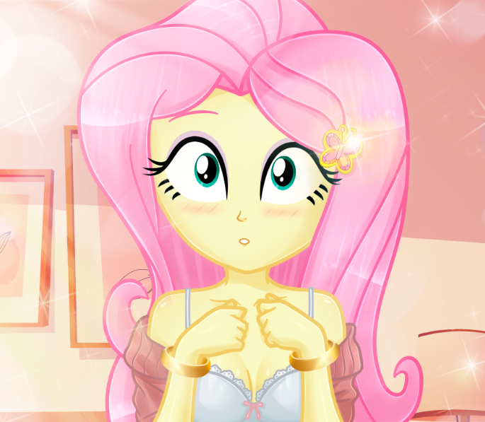
Fluttershy: AAAAAAAAAAAAHHHH!!!
You: WHOAAAAAAAAAAAAAAAAAAAAAAAAAAAAAAAAAAAAA!!!!!
OMG, sweet lady of fortune that has brought me here! *0* .. Fluttershy in front of me… about to undress?!:D
In my instinct to avoid another misunderstanding... I close my eyes and begin to bump into whatever is in that room XD…
You: I didn't see anything I swear... I didn't see anything... nope... nothing!! Im here because I heard you scream and I was worried about you!
Fluttershy: eepp!!... be careful!… i mean… i only… be careful!! Dx
*SLAM* *POOM* *SQUASHHH*
Even with my eyes closed, I stumble and stumble and I don't stop stumbling Dx... but I don't mind getting hurt or badly hurt!! This is a misunderstanding! ...that's when I finally find the door.
You: I'll come back later and ….
However... I feel like something is pulling me …
Fluttershy: … open… open your eyes please…
EXCUSE ME?!!
You: i cant… i mean… no, im sorry but i cant >-<…
With my eyes still closed, I feel Fluttershy's hands on my face... then it is she herself who prompts me to open them and look at her O_______o…
You: *gulp*
Fluttershy takes a few steps back... still with her clothes about to fall off her body. Her gaze is focused on my eyes, while her face reflects an intense red color… I am perplexed… I don't know what to say or do… what is happening!!!
Fluttershy: … you…. You really think that im pretty?
OH MY…
You: of course yes >///<…
Hold on champ, I feel the nosebleed coming!! .. Fluttershy walks towards me again and puts her hands and her head on my chest …

Fluttershy: your heart… is beating very fast… just like mine.
At that moment, Fluttershy takes my hand and brings it to her chest…. WAIT WHAT?!! CHARLIE I LOVE YOU!! I mean no, I hate you!! What is happening…this is not right!! I've been through this before and although I would like to live the dream again, this story has to be family friendly!!
You: QWDSASAHGDGJNMN!!!...
It's so soft!!!! OH GOOOOOD... Don't fall into the temptation of sin!! It's a test... that's it!!
You: Fluttershy please… I'll come back later and…
Fluttershy: no… I dont want you to go >///<
You: …¿?
Fluttershy: I.. I… *sigh* … stay with me ….
Fluttershy begins to slowly take off her sweater and skirt... leaving only her underwear while she slowly begins to kiss my neck...
You: DASUIDSAHJDKAS!!!
I'm completely paralyzed!!
You: Fluttershy!!... I… you.… x___X
Fluttershy looks at me again, this time with eyes determined to achieve a goal...
Fluttershy: I want… I want you and me to be together… please … >///<
You: Hey, you can catch a cold!... I mean... but we're already together now, right? o_o
Fluttershy: I mean... do with me the same thing you did to Rarity! >_<
WHAAAAAAAAAAAAAAAAAAT???!!
You: whaaaaaaaaaaaaaaat???!!!
Pinkie Pie: WHAAAAAAAAAAAAAAAAAAT???!!
CharlieXe: WHAAAAAAAAAAAAAAAAAAT???!!
You: Pinkie and Charlie?! Get out of here you don't appear in this story! Dx
Pinkie Pie: oops… you right.. bye! :D *cueck*
CharlieXe: that's why everyone hates you ¬_¬… *Im gonna play Megaman X* bye.
You: Hey… I don't know what Rarity told you but absolutely nothing happened… or at least… I don't remember… I passed out half the time… but NO! Nothing happened!!
Fluttershy: even if nothing happened… I want… I want to be with you… I want you to see me as a woman! >_<
You: *sigh* … Let's see... Fluttershy. First of all please… get dressed… I'm about to faint with a nosebleed and I really want to talk with you x_x.
Apparently she barely sees my face with a serious expression and being determined not to look at her while she's in her underwear, she tries to cover herself with her arms completely embarrassed >_<. After a few minutes, I go back to her room...
You: Hey…
It’s time for me to face this like a man…
Fluttershy: hmm? * Fluttershy looks at you *
You: This isn't about you or the other girls…it's about me. I have to work on myself as a person. I had a past as a thief that I'm not proud of, and well... what happens if I go back to the way I was before? I could never forgive myself if you or the other girls end up suffering because of me...
Fluttershy: *sigh* Really I'm the one who should apologize to you. I was being selfish, I only thought of myself and I didn't think of you…
Fluttershy looks at me again with a serious expression. …
Fluttershy: even so… would you like to have a real date with me this Sunday? >_< …
You: oh… real date? Ahmm… sure hehe
Oh my… I already have new plans for this Sunday with the pretty Fluttershy!! :D…hooray! It seems everything went well today, right? O.o.. At least I didn't get slapped for seeing Fluttershy in her underwear!! *0*

-Sunday… a few days from the fake wedding with Pinkie-
Fluttershy: Days ago I decided to invite our dear friend on a date . I want to make it clear to him what I feel for him is not a game... I want him to know that I really have feelings for him ^^. Besides, I am completely prepared and psyched up. Come on Fluttershy, you can do it .
It's noon. I walk a little nervously to the place where I told him we would meet: in front of Canterlot High School. I guess it's a pretty common place for us, after all, we study there. Many things have happened: I remember when Sunset turned into that giant monster hehe, and it was the first time I saw him, running and hiding inside the school ^^. Oh, then those girls showed up: The Dazzlings. Adagio, Sonata and Aria… how to forget when he tried to talk to them, but was totally ignored by the girls… I guess he was trying to be friends with those girls. I saw him very shy, he really reminded me of my days where I also wanted to make new friends. When the Dazzlings transformed into their equestrian forms, he couldn't believe it :O. He didn't seem scared, though, just…intrigued. However, seeing the projection in her siren forms, he really ran away hehe ^^. Then came the Friendship Games, and we had serious problems with Twilight and her Midnight form… for the third time we were in danger, but this time something changed in him. He saw everything and he didn't run away like in the previous occasions and not only that, I saw him try to help Twilight… I mean, that was his intention I'm sure. Although he couldn't move in fear, he didn't run away. He really was very brave O_o. Unfortunately he didn't go with us to Camp Everfree, I guess that was a good thing as he would have had to deal with another problem again, which was Gloriosa Daisy.
After all that, he was the one who talked to us… or to tell the truth, to Pinkie. He needed to go to his classroom, but Pinkie tricked him into going to the library by telling him that the class would be held there, which was a lie U_U. It really made me very sad. So, that was the beginning of this whole trip… we became friends, we went to that resort, Pinkie wanted to take a picture of him but the flash temporarily blinded him and he touched Applejack's… butt ehem… but it was unintentional! >_<!.
Or when me and the girls went to Rarity's sleepover, and he appeared out of nowhere just as Sunset was wearing a black babydoll. Awww. Really Pinkie not only tricked him, but she tricked us too U_U. Although the most beautiful memory I have with him was when we went on that study trip and Principal Celestia rented some cabins. The next day I woke up and he was by my side… we really slept together heehee ^///^.
Many other things have happened up until now, including my “fake wedding” with him, which is when I admitted that I was in love with him. But… he didn't seem impressed, or rather, he didn't react at all. I guess it's my fault for having many hope, as if I waited for him to answer me: "I love you too Fluttershy." It was very silly of me hehe, after all, girls love him too… I'm not the only one fighting to win his heart. But for some reason, I think im being the last one, I've been about to give up… he just doesn't see me as a woman, he doesn't see me as a partner, as his girlfriend. And that really hurts me a little bit.
I feel that he sees me as a younger sister, he always tries to take care of me and protect me. But sometimes I don't want that, I want him to hold my hand, I want us to walk together, I want to eat ice cream with him, play video games together... kiss like any couple in love .
Sometimes I also admit that I am very envious of the other girls. But I… I haven't tried again. I didn't get a response at the time and im afraid, but that's what this date is for, I want to change that! Today I will receive an answer I am sure!
…
_______________________________________________________
Fluttershy and I are going on a date today! Yay! I'm so nervous, but refusing an invitation from one of the prettiest girls in school would be ungentlemanly! So, here we go fella!!! :D
Fluttershy: hi! :D .. sorry, did you wait for me? ^^’
You: Oh don't worry, I just got here anyway. you really look very pretty
Fluttershy: re-really? º///º …
You: Yes! I feel very lucky to go out with you , and this will help me take away this stress that I have for… well, you know e_e.
Fluttershy: yes hehe, your fake wedding with Pinkie. Are you nervous about it?
You: to tell the truth… it is a situation that I have already gotten used to. I mean, I'm getting married again tomorrow, but this time with Pinkie, just to promote Mr. Shamrock's wedding dresses. It's not bad, they pay me for it but… it's uncomfortable, you know?
Fluttershy: Do these photo sessions bother you?
You: not the photo session. It’s the marriage.
Fluttershy: !?
You: So much wedding scandal and stuff is not necessary, when what really matters here are the dresses and you modeling them. Why I have to make a fool of myself wearing a tuxedo and posing for photos when I could be in the arcades with my friends hehe... XD
Fluttershy: …
You: huh? Something wrong Fluttershy?...
Fluttershy: … It means nothing to you?
You: …
Fluttershy hides her gaze. She looks sad... She is much more serious than usual… ahmm I say something wrong, right?
Fluttershy: I see… I'm sorry but… the best thing is that we canceled this. I- I don't feel very well. Bye.
* Fluttershy runs out of the place leaving you alone *
You: Fluttershy wait!!! …. Fluttershy!!
…
…
_______________________________________________________
I see... that's it. Are we nothing to him? I am really nothing for him *sniff*... Would he have preferred to be in the arcades instead of being with me when I modeled that dress… in our wedding?…
???: You don't have to be sad, girl.
Fluttershy: huh?!

???: I can help you and it’s very easy.
Fluttershy: what?
???: You don't get it? You shed your tears for someone who doesn't value you! You are much more than that, and you have to prove it.
Fluttershy: I... I want to be with him... but it's clear that it seems that he doesn't feel anything for us, or for me.
???: Then prove that he is wrong. Remove that vague idea of ​​​​yours that you are the last one and take flight. Take off and rise like the phoenix… be a new woman.
Fluttershy: but... how do I do it?
???: I will help you. There is a very powerful emerald that with it, you will be able to be with him without worrying that someone will get in your way. Don't worry, trust me and everything will be fine.
Fluttershy: … who... who are you …
???: hmm… you can call me… Sombra.
_______________________________________________________
…
…
- Present –
That man, Sombra... he has Fluttershy under his control! We must do something to help her!
I know Fluttershy is suffering and I can't let her continue like this!!... It's time to help her... we must do something to make her go back to being the same sweet girl she was before!
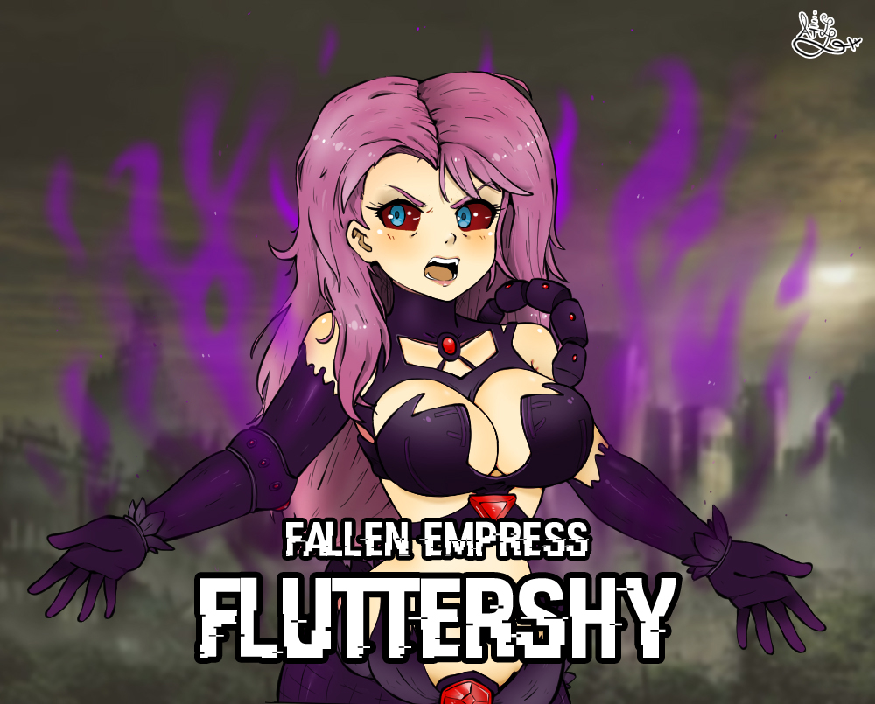
(drawing by @osotvgames_hd)
You: Fluttershy please!!
Fallen Empress Fluttershy: Darkness reveals our truth, and I suffered this for you!
Fluttershy charges at me again to attack me. I can't believe it, she really hates me!...
Of course I try to avoid all her blows but it's useless, she's too fast for me. I switched to my defense stance, increasing it. I can't dodge their blows so my only option is to block them with my body!
Sunset: Fluttershy stop right now!! You're hurting him!!
Fallen Empress Fluttershy: shut up! He will feel my pain!!
Pinkie: Fluttershy!!!
Fallen Empress Fluttershy: SUFFER AS I HAVE!!!

At the moment when Fluttershy was going to give me what for me was the final blow, Rarity managed to do a crystal wall strong enough to protect me. However, upon contact with Fluttershy's punch, the crystal wall instantly shatters! At least I was able to survive thanks to Rarity!!
Rarity: You have to stop girl! Look at you, you are unrecognizable! We are your friends!
* Rarity looks at the rest of the girls. *
Rarity: It's pretty clear that Fluttershy wants to hurt our darling. I don't know why she's doing this, but if we don't fight back, this will get out of control!
Sci-Twi: That resentment … where resentment and hatred come from.
Nightmare: I already told you. This powerful new transformation is none other than the true feelings of this girl, Fluttershy. I never had to intervene, her heart was clouded with that black feeling of hatred and resentment for you... for that young man.
Doppy: listen to me… as long as we don't defeat Sombra, you friend won't come to her senses. You, Twilight, are smart! Think of something to keep Fluttershy busy while I take care of Sombra!
R. Dash: What are you talking about, you are very hurt! That man will destroy you!
Doppy: If that happens, I'm not going to hell alone. I'll take him with me! Now work as a team and help to your friend!
All of us are dumbfounded at my doppelganger's words... it's the first time he's not acting like an idiot or a pervert. He really is taking this very seriously, and not only that… is he even considering protecting us from Sombra even by giving his own life?
Applejack: What are you thinking to do…
Doppy: everything necessary to see that man fall before me. He already made fun of me once, I won't let him do it again!
Doppy runs towards Sombra to face him one more time! While me and the girls, we have to worry about how to help Fluttershy to become the sweet and cute girl that she was before!.
_______________________________________________________
…
…
I can't believe that I, the greatest warrior of the Underworld, the one who had the entire city under his feet, has fallen under the noble hearts of those girls. Now I not only fight for them, but I am capable of anything to protect them... what has happened to me!!
Doppy: Sombra! You better be prepared, because Im gonna be your opponent!
Sombra: So be it, you little vermin. Hehehehe…
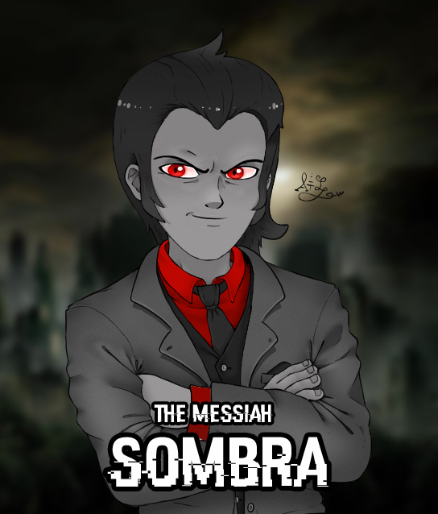
(drawing by @osotvgames_hd)
Sombra: This will be you last challenge. Gravity Well!!
“Gravity Well: It is an attack that allows to create a non-destructive micro-black hole. It slows down everyone around it, except for the catalyst of the attack.
Sombra: hehehe… you already tried it once and it didn't work... what makes you think that this time it will be different.
Doppy: Now I have something up my sleeve! Hehehe!
I start attacking him as fast as I can even while under the effects of his “gravity well”. However, I didn't manage to land any hits!! Sombra on the other hand, just laughs in my face… that's when he lands a powerful direct hit!
*PUNCH!!!*
Doppy: Arrghh!!! Dx
Sombra: Enough is enough… I created you, and just as I did, I can easily destroy you.
I quickly managed to get to my feet and continue on my offensive stance. Sombra is like the final boss of those video games, so beating him won't be an easy task. Sure, I can always use Destiny-Bond, but I need Sombra to be distracted by something so I can channel the bond and use it against him.…
???: Take this!!
*FLASHHH*!!!
Out of nowhere, I manage to see a kind of "razor" of light in the air that goes directly towards Sombra, but he manages to dodge it. With an astonished face, I decide to look where that attack is coming from, and I can see some kind of portal... it's a very blinding beam of light, but once the light dissipates, I manage to see a man with a huge sword.
???: …
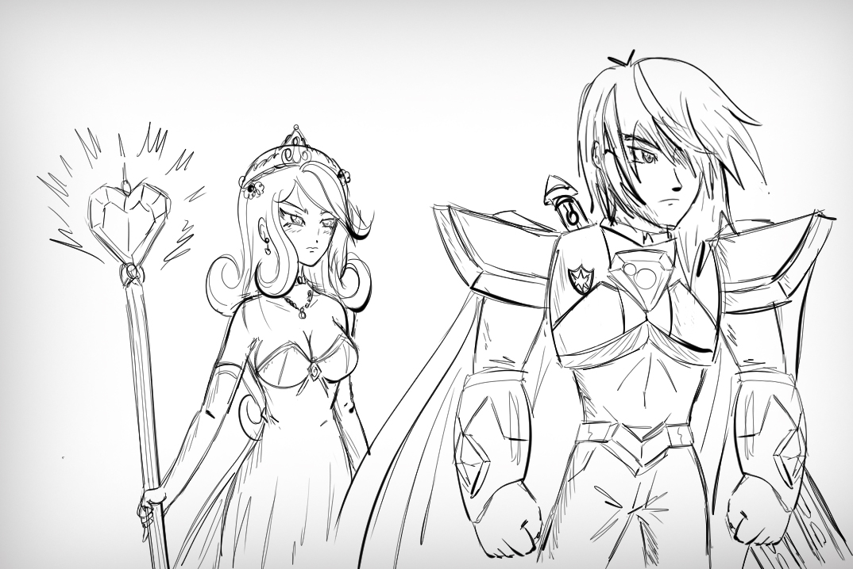
Sombra: Shining Armor…
Do these two men know each other? And that man Armor, isn't he the same one who goes to my Crystal Prep school?!!
Doppy: hey what are you doing here?!! Why are you wearing that armor?! And why do you have such a great sword and I don't! DX
Shining Armor doesn't even bother to look at me or answer me, his gaze is focused on Sombra, it seems that those two men are rivals or something like that :O.
Princess Cadance: It's a long story, but there will be time to tell you everything.
Doppy: P-Principal Cadance?! You too? O_______o
What the heck is happening here!!
Starlight: Let's say there are two parallel worlds where we have counterparts from another species, and when they cross into our world, they do so in human form.
Doppy: I guess that's enough for now...
Starlight: Princess Cadance… im sorry but…
Princess Cadance: Don't worry Starlight, Celestia has told me everything and all of Equestria is aware of Sombra's plans. You cannot fight this battle alone, he is too powerful. My husband decided to intervene for the good of both worlds.
*Cadance look at Sombra*
Princess Cadance: I also have unfinished business with you, Sombra.
Sombra: That time it was just a slip on my part, but I promise that once the emerald is in my possession, I will go straight to your Crystal kingdom and destroy it with my own hands.
Shining Armor: You forget that you have to go through me first.
Doppy: hah, Don't expect me to let you take all the glory from this fight.
I personally don't understand what is going on here: Two worlds where each of us has a counterpart? I mean, there are 2 Cadances, 2 Shining Armor… and 2 Doppys? Hahaha XD. I would like to see my counterpart!... Oh sure... I already have my own... the other idiot -_-'.
Shining Armor: hey you…
Doppy: huh?
Shining Armor: All of us saw you fight: me, my sister Twilight, my wife, even Princess Celestia... and you have proven your worth as a true warrior even when your past dictates otherwise. It's amazing that you would have decided to fight Sombra even though you know you can't win, and all to protect your friends.
Doppy: heh, now will you give me a medal or something?
Shining Armor: No, but you've earned our respect, and deserving of a noble title once we're done with him.
This version of Shining Armor is a complete badass compared to the one I know from my school! I'm honestly not interested in his respect, but… a noble title? YAY, I like that! I can use it to meet high society girls!! *0*!
Doppy: hahah! Now I have a real reason to destroy you Sombra!! And you, Armor, we're going to beat this man!
Shining Armor: I count on you!
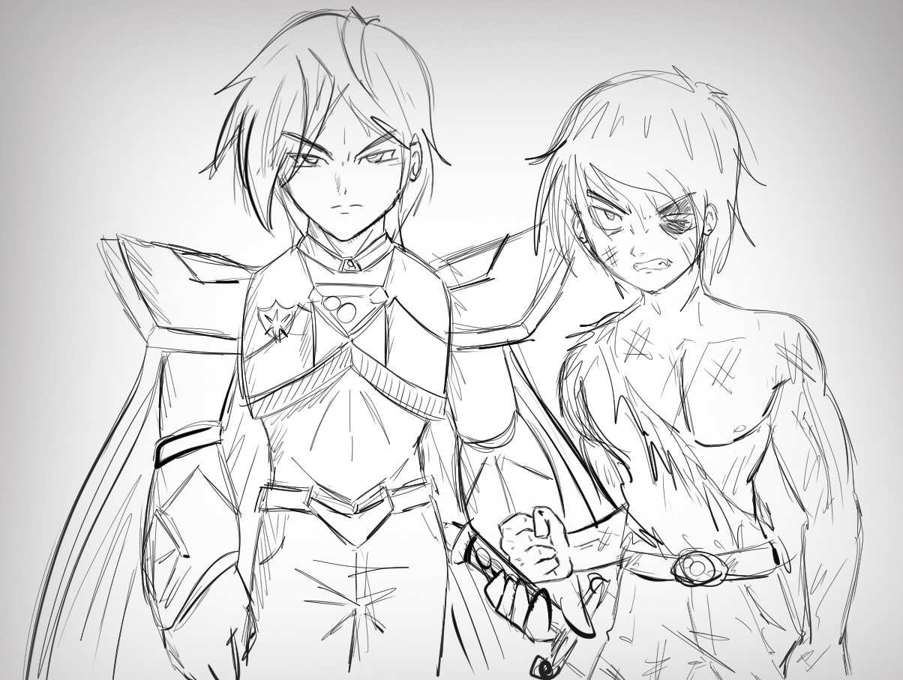
…
…
That emerald is inside an amphora, whose name is: "The traveler's amphora." It belonged to Clover the Clever, who was on a mission to hide it due to its immeasurable power. Such power could not come from anywhere other than the Underworld, here is the mystery of how such power came to the pony world. Clover traveled to the human world using the same power of the emerald, and hid it in some corner of that world, hoping that no one from Equestria could find it.
But somehow, Sombra has returned as a human and a deity, and he knows all the secrets of that emerald, he only needs to know its location, which is still unknown. It is believed that you may have obtained it at some point when you were a thief in the Underworld working for the Storm King and Cozy Glow. But it has been concluded that such an emerald probably has an ability similar to the Memory Stone if you touch it only with your hands, then you don't remember having obtained it, but Sombra is sure that you are the key to finding its current location and use it for his benefit: Create multiple portals and rule with an iron fist all existing dimensions and alternative worlds, since such an emerald has the ability that its bearer can distort space / time at will, traveling between dimensions and even, change the history.
Princess Celestia: That young man and the girls are still trying to convince Fluttershy to come back with them, while Shining Armor and that boy they call Doppy, will face Sombra with the help of Cadance.
Twilignt Sparkle: I need to go with them and help them!
Princess Celestia: No! Twilight, we are the protectors of this world, and though it hurt to say it, we must be prepared in case Shining Armor and Cadance don't make it. We have an obligation to stop Sombra if he achieves his goal in the human world.
Although Twilight doesn't want to admit it, Celestia is right... she along with Pinkie, Rainbow Dash, Fluttershy, Rarity and Applejack have to be prepared to confront Sombra in case Doppy, Shining Armor, Cadance and the girls fail to the defeat him. We don't want that to happen, but it is an option that we cannot ignore.
Will they manage to stop Sombra in what it is, the final battle? :O

TO BE CONTINUED…

