Costume Draw
A Short Story
By Maryanne Peters

It sounded like a fun idea: Pick a costume out of the hat. Everybody at work was playing. It is that kind of team. Then I reached in an picked out my card and unfolded it. “Blonde Bimbo Prostitute”.

“How perfect for you,” somebody said. People tousled my naturally fair hair which had been in need of a cut for weeks. Everybody had a laugh at my expense. They started coming up with suggestions for a name – names like “Trixie”, or “Coco”, or “Roxy”.

“Swapping is not allowed,” people said. I was stuck with it.

I was not looking forward to it the way others with better costumes were. I suppose that is why I left it until time was almost up before I went to find the outfit that I needed.

Fun-time Costume Hire was on the second floor of a building not to far from my apartment. It was late Thursday when I go there. I had just been avoiding getting the costume, but with only two days before the party I needed to act quickly.

“You must be from the Halstead Call Center,” the girl behind the counter said. “Some of your co-workers have been in already. The last of them on Monday. What’s you costume? I hope that we have something for you in stock.”

I had the card in my pocket. I slipped it across the counter. She looked at it, but she did not immediately smile. I shrugged my shoulder.

“Let me measure you for size. We have something that I am sure would meet the bill,” she said. “A body stocking with inflatable breasts and a tacky blonde wig. But can I say, you could do a lot better than that.”

“Show me what you have,” I suggested.

She laid out some stuff with a blonde wig on the top. I put it on my head clumsily.

“I suppose that I am supposed to look cheap,” I said.

“I am the wrong person to say that to,” she said. “I needed to sell some tricks when I was young. I am a wife and mother now, but I will never forget my time in prostitution. It is demeaning enough to sell your body, but I never stooped to pretending to be a bimbo for customers. There were requests, I can tell you, but pretending to be dumb to be more attractive to a man is demeaning to all women.”

“It’s not my choice,” I said. “I drew the card. As for bimbos, I’m with you … sister.” I added the last word with a swish of the blonde wig, to try to get a smile out of her. She resisted for a moment and then grinned.

“Be a sister then,” she said. “Forget that wig. Let me take you around the corner to the salon run by a friend. It’s late so I’ll finish up. We will leave this stuff behind. Let’s make you a prostitute to be proud of. One too pretty to sell cheap. I promise you that it will cost you no more than this costume.”

The last costume party some people had gone all out. Nobody appreciated those who just turned up with a costume off the peg. There were prizes for the best costumes – sometimes quite good ones.

“Ok,” I said.

“My name is Maude,” she said extending her hand. And within a few minutes I was also taking the hand of her friend at the Salon, Hayley.

“At last a natural blond,” said Hayley. It is so obvious. I am so fair that my eyebrows are almost invisible, and my eyelashes too. “And enough hair to anchor some extensions to. You’re right Maude, a wig would be a crime with hair like this.”

“You are not going to do it tonight, are you?” I said.

“What are you doing tomorrow?” Hayley asked.

“Going to work as usual,” I said.

“Take Friday off,” she said. “Call in sick and come in here and help me out at the salon in return for everything I am doing for you. I am short-handed tomorrow. Do you think that you can wash hair like I am doing now?”

“Sure, but … what exactly have you got planned for me?”

“A makeover,” she said. “Body and soul. Something that will make a beautician like me want to spend an extra two hours at work after closing time. What do you say, Maude? Can you stay and help me?”

“For a bit, sure,” said Maude. I can do his legs.”

“Her legs,” Hayley corrected. And to me she said: “We need to give you a name to match your new sex.”

“Like “Trixie”, or “Coco”, or “Roxy” maybe?” I volunteered.

“Certainly not!” Both women were frowning. “A high class call girl … Miranda,” said Maude. And so, Miranda I became.

I did take note of the way she was washing my hair. I had not agreed to getting a sick day off to work in a salon, but I liked the way she was doing it. It was very relaxing.

Through that and the beginning of the hair extending, Maude took to my legs with what I thought was a razor but ended up being some kind of hair pulling tool. She first rubbed the legs with an astringent to numb them and lift the hair and then she ran over them with this tool and I hardly noticed.

“I have to go,” she said. “I have a husband and children to attend to, but I will come back with some stuff in your size.” And then she was gone.

“You are going to look great,” said Hayley. “You are going to look like a woman, not a man dressed as a woman. So, you need to walk and talk like a woman. You can’t talk while I am working on your hair. This is intricate work, but it will be invisible. But you can talk, so let’s see if we can get you voice up to feminine levels.”

So, I talked, and she coached me. She coached my voice up, and up, and up.

“Now is the time for the makeup,” said Hayley. “You have such long eyelashes but completely white and virtually invisible. When I curl these and use the right mascara you won’t need false eyelashes.”

She turned me around from the mirror and went to work on my face.

I must have been there for hours because just before she was finished Maude reappeared.

“Oh my God,” she said. “Miranda. Miranda you look fantastic.”

I could not wait to see, but Hayley had a few finishing touches to make before she spun the chain back around to face the mirror. And I could not believe what I saw.

My first thought was that this was some kind of well-engineered trick. They had found a woman to sit behind glass where the mirror was a feign a look or total surprise. But no. This was a mirror. This was me looking back.

The hair hung simply over my tee-shirt without any indication that it was not my hair. But the face was so feminine that I could not believe that there was a man in the room. The face had been covered with color, the eyes and eyebrows had been painted, and the lips just coated with a little pink lipstick. That was all.

This is how you will look tomorrow too,” said Hayley. “And the day after that – the day of the party – we will add a little extra. But will you be working at the call center tomorrow, and explaining your appearance, or will you be calling in sick and working here with me?”

“Here,” I said. “Here with you.” The words that came out of my gaping mouth were in the feminine voice that we had been working on, now suddenly automatic given what I was looking at.

Maude’s hands went to her face. She said: “And listen to that. Miranda has arrived!” She reached into her bag and pulled out some clothes. “And I have something suitable for you to step outside in, and something to wear to bed, and to work in tomorrow here at the salon.”

And I walked home in a dress and heels, put on my nightie and went to bed.

I had to wear the same dress to the salon in the morning, and it felt wrong. Somehow, I had an idea in my head that with the clouds around, I should be wearing something a little different. Where that idea came from was a mystery to me.
Equally as strange was how comfortable I spent working at the salon. The day before had been the first time that I ever set foot in one, but now wearing a dress and washing hair and chatting with all the female customers, I felt completely at home.

I started out washing hair, but as I was told, nobody can continue doing that all day – it plays hell with your hands. I was moving onto hot waxing.

That seems simple, but it was explained to me that there was a technique, and who better to demonstrate on but me.

There is nothing that can give a person better understanding of the pain of others than to suffer it yourself. And that means both legs.

“It’s Friday night and we always go for drinks after work,” Hayley said. “We’ll ask Maude to join us, and bring you something to wear. Something more suitable for an evening on the town. Something that will show off those gorgeous smooth legs of yours. We’ll put some soft curls in your hair.”

“I am not sure if I am ready for this,” I said.

“Nonsense. Her is a chance for you to test your skills and speak with you new voice, while being fully supported by your co-workers.” Everybody looked at me. There was no turning them down.

The closed sign went on the door and while I swept the floor, being already made over, the other salon girls got themselves ready. Maude appeared with a tight fitting knit dress, black tights and heel. The idea seemed outrageous, but the look was fantastic. I looked in the mirror and saw the kind of girl I wish I could meet on a Friday night.

We went to a local bar and set about having guys buy us drinks. Apparently this was a weekly thing, and I just went along with it. The price is that you have to talk with guys, or rather listen while they talk to you about themselves. But I worked in a call center so I am a good listener.

Then when the time comes the girls (including me) and regroup to move on.

I really should have quit earlier, but the others were keen to keep going. And in the last bar I met Carson Bailey. I suppose that I knew that he was different because he wanted to know about me. I had nothing to tell him, for the simple reason that I did not exist. I could have lied and invented something, but somehow for this man, that did not seem like the right thing to do.

“You look fabulous,” he said.

“I don’t always look like this,” I said, in the girly voice I had been practicing all day, to the amusement and approval of my salon colleagues. “The truth is that I am just dressing up. I am going to a costume party tomorrow night.”

“I love costume parties,” said Carson.

“It’s a work thing, otherwise I would invite you,” I said. I knew that it was a stupid thing to say, but somehow this guy seemed to make me stupid.

“You mean that none of the people you work with are bringing partners?”

“OK,” I said. “I suppose others will be bringing a partner, but you don’t have a costume.”

“Well actually I do,” he said. “So, you had better tell me where it is happening.” Somehow he had invited himself, or I let it happen.
I woke up Saturday morning, a little hungover and dressed in my nightie, with makeup smeared on my face and pillow and my blond curls crushed. I decided to go back to the salon which opened for Saturday trade. I needed to be there for my costume, but I could help out until the time for that came around.

The girls teased me about the man that I was with. Hayley said: “You were holding his hand.”

“Was I?” Was I that drunk? I didn’t think I was.

“Sit down. It’s time for you makeover,” said Hayley. “We need curlers for volume and then we are going to put your hair up. The look we are agreed upon is not a street prostitute – that would be demeaning – we will be looking at a high-class escort.”
When I was ready for the party, but before I had a chance to put on my classic pink gown, I got a call on my cell.

“Hey Melinda, It’s Carson here”. I looked around the salon. I would have to talk to him in my girl voice and they would hear me. I went outside the salon to talk.

“How do you have my number?” I asked him.

“Your friend Maude gave it to me,” he said. “She works at the costume shop I have just visited to pick up my Prince Charming outfit.”

He was planning on being my date to the party. The idea was crazy, but the truth is that I had never had a date to any work thing before. I am sure that everybody thought that I was a freak, or maybe even gay. Well, if I turned up with Carson then I would be. But did that matter?

“Carson, I am not sure that you really want to go out with me,” I said. “I am not who you think I am.”

“I want to meet the real you,” he said.

I did not know what to say. If I look a little blank it is because I was. It was because in that moment and for the rest of the day, I am not sure if I knew what the real me was. I could feel like myself – the same person I had always been, so long as I did not look in the mirror, or as long as I was not with Carson, looking at me as if I was the girl in the mirror. Because as long as he looked at me like that, I was that girl.

I watched her in the mirror as Maude helped me to put the dress on. It had a jeweled clasp on the shoulder and earrings to match. It was off the shoulder but in front it had a rigid bodice so that the flesh on my chest could be pushed up to create a realistic cleavage, highlighted with makeup and concealing gel inserts that moved like the real thing.

“I don’t look anything like a prostitute,” I whispered to Maude in my girly voice.

“You look like a princess,” she said. “And I have dressed your prince charming too, in mock Victorian military uniform with a sash and star. You will look wonderful together.”

“I am supposed to be dressed as a whore.”

“How much of that you are will depend on what you do after the party,” said Maude.

“What are you talking about?” I exclaimed. “I am stepping into a nightmare. What will he do to me when he finds out?”

“Your limousine is here,” Hayley called out. She came over check that my hairdo was is place. She gave me a small bag and said: “There is lippy and mascara in here so you can refresh as I showed you.”

And just as they pushed me out the door, Maude whispered: “Don’t worry. He knows.”

Was I relieved or disappointed? It hardly seemed to matter as Carson never once led me to believe that he knew as he opened the door to the limo, and held my hand as we were driven to the party.  He stood back to let me walk up the steps of the venue, to admire the way my dress hugged my round butt, the smoothness of my pale back, and the perfect hairdo.  He never even let on when my work colleagues approached me, initially as if I were a stranger, followed by confusion, then amazement.  “Only a high-class prostitute would arrive with a prince on his arm,” I explained.  Carson never treated me as anything less than the lady he could see, or feel on his arm or in his embrace on the dancefloor. He really was the prince charming of every girl’s dreams, including mine. | 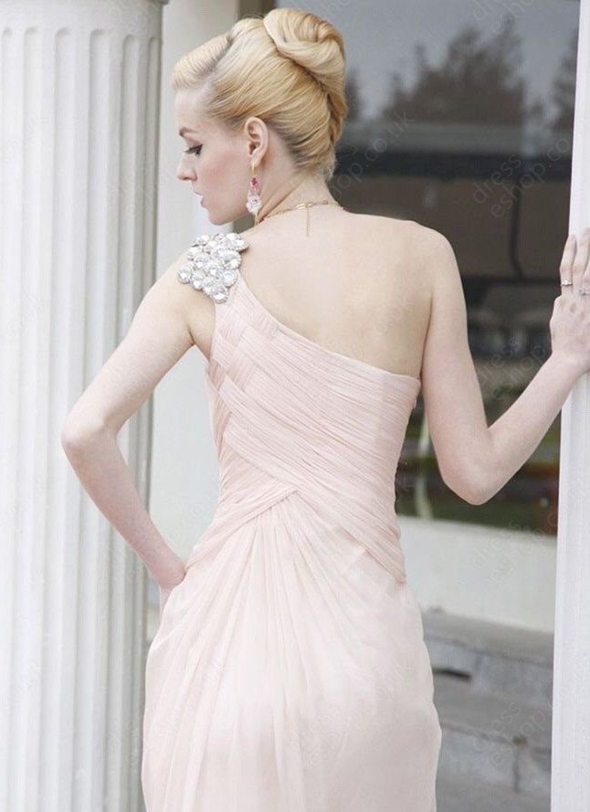

The End.

© Maryanne Peters 2019

