The Pageantry Trap
A Short Story
By Maryanne Peters

You can probably guess how it began. It’s in the title. It was a beauty pageant, more than one in fact, but the first one had to be a “Womanless” Beauty Pageant.

My mother had been a beauty queen. She married my father who was an athlete and a pro ballplayer when they met. To his great satisfaction he had three sons. I was the youngest. We were all brought up to play sport as our father had. None of us had the slightest interest in domestic things. We wanted nothing more than to be like our dad.

I think that my mother always missed the fact that she had no daughter to beautify and exhibit. She loved us all, and often said that she was lucky that she did not have daughters to disappoint her. But even by saying that, I am sure that she felt that she had missed out somehow.

Dad said that our task was to make sure that the girls we married would not disappoint our mother. That was how she would get the daughters she never had.

But that is not the same as bringing up a girl through those important years, when she becomes a young woman; when a mother can shape her daughter into something special. Mom would never be able to do that.

In previous years, she enjoyed the company of women who had daughters about the same age as my older brother, and sort of “adopted” some of his ex-girlfriends to act as their mentor. One had even entered a beauty pageant and done very well. My mother was very proud. But all of those girls had moved on to college as my brothers had, so there was a gap in her life.

Still, it was not her suggestion that I enter the competition. It was my girlfriend at the time, Gemma Halpine. I say my girlfriend because we sort of went out on a few dates, mainly with others, and she called me all the time, just to talk. We made out. I was keen on sex, but she was not open to that idea at all. We were still too young, and she was a bit religious.

She was round at my house one day and she was looking at some pictures of my mom in her pageant days. I remember that she said: “You have the same eyes and cheekbones as your mother. With the makeup like she is wearing, you would look just like her.”

Then, a few days later she came over with details of a “Womanless” competition as a side-line to a regular pageant in support of a charity. She suggested that I should enter. There was a cash prize, and as she pointed out, I could compete anonymously. It was not a school thing, as these stupid vice-versa pageants often are. If I could do a good job, and not look like me, nobody at school would know.

“Great. But why would I want to do that?”

“I think it would be fun,” she started. Then seeing that I was unconvinced, she added: “I think you would be really sexy as a girl.” And then, to finish me off she said: “I know you want to have sex with me. I think a little girl on girl action might be on? That is not real sex, like in the Bible.”

I had done my bit with this girl but had never got beyond “heavy petting” as they call it. Whenever a hand went below her waist it was smacked away. She had driven me crazy before now, but the look she gave me in that moment sent me over the edge. There was nothing I would not have done to get inside her at that moment. Nothing.

“Sure. Ok.”

Gemma told my mother immediately. I was surprised that my mother did not immediately leap at the idea, after all I have just said. She looked very worried. Maybe she had a premonition.

“Do you really want to do this?” she asked me.

“Why not” I shrugged. “It will be a blast. But nobody can know its me. That’s the deal here.”

“When I am finished, you won’t be you at all,” she said. And it turns out that she was right.

Both Mom and Gemma insisted that I take it seriously, so I did. I guess that we learned that from Dad – if you want to win, you have to commit yourself totally to the task in hand. I don’t think that he approved of the whole thing, but he did agree that if I had signed up for it, I needed to do my best. I could not be just half a girl, I needed to be the whole thing.

I did not have much hair on my body, but what I did have went down the drain. I had the advantage of good skin on my face, and a little plucking on the chin the brows was all that was needed. Not too much off the brows – just enough so they could be brushed into a feminine arch and then scuffed back to look like a guy’s eyebrows.

Mom was able to put together a body stocking to give me the shape I needed and to fill out the prom dress outfit I wore.

I wore a wig that first contest. I could take it off at the end of it and be me again. But while that wig was on, I was to be Celeste, my feminine alter ego.

What surprised me the most was just how easily I slipped in to being Celeste. It surprised my Mom too. It even made her cry, when she stood back after she had done my makeup and I struck a pose. I could not really understand why she was crying. She said that I was just like the daughter she had always wanted, in my actions rather than my look.

“I have the best example to follow, Mom,” I said. “You always carry yourself so well.” I meant those words, because somehow, I noticed. I realized that I had always watched her, and admired the way she did things, and now all of that observation paid off in an ability to present myself as completely feminine.

That is what won over the judges. My look was great too, but the head judge was involved in some school teach “deportment” (whatever that is) and she complimented me on my walk and my gestures. “Totally convincing” she called it.

Having not only done the contest but won it, I was expecting big things from Gemma, but still I never got to penetrate her.

“It’s girl on girl,” she said.

It was the first time that we went to bed together, and we went to work on one another, but we both kept our pants on. I came in mine. Maybe she did in hers? She really did not have much in the way of tits, and of course I did not have tits then.

It should have ended there. I should have ended it with Gemma because it was clear that I was not going to get laid. Dressing up as a girl should have been a once only thing. That was how it should have been. I should have gone back to being me. But I couldn’t.

Part of the problem was that there were photos of me at that contest, or rather photos of Celeste. She looked fantastic. Mom kept one on the fridge and she kept looking at it, and then looking at me eating my cereal and she would smile. But I kept one too, in fact several of them. I would look at them and then look at myself in the mirror. Celeste was still in there and I could not make her go away.

Then Mom showed me the flyer for the “Mother daughter pageant” in a neighboring city. I shook my head furiously, but she did not even have to use words to plead – her face said everything.

As I said, my mother was an ex-beauty queen. It turns out that you cannot simply shake that off. It gets into you somehow: The preparation, the demonstration, the admiration. I understand how some girls get hooked. My Mom wanted to step out onstage yet again, with her daughter. She did not have one, so that was me.

Again, my father did not really approve, but he knew that this contest meant a lot to Mom, and what she wanted, he wanted her to have. “Do your best, Cal,” he told me. “Make your mother happy, and me and your brothers won’t think any less of you.”

I was worried about what they thought, especially when my mother told me that for the contest I was going to have to have longer hair. I said before that with the first contest I could simply take of my wig and wipe of my lipstick, and I was back to me. When your hair does not come off, and when you have to comb it and tie it at night, that is not so easy.

I did not have short hair like my brothers, but it was not long hair. But my mother said that it was long enough to have extensions put in. I asked her why it was necessary and she said that the contest was being sponsored by a salon products company, and our hair would be styled before the show using their products – no wigs were allowed. The extensions would have to be good quality, and could only be added just before the contest, so I could go to school.

“But there is other stuff that needs to be done in advance,” Mom said. “So you will need to have a few days off beforehand. She was talking about a heavy facial including stripping every whisker from my lip and chin, and using deep moisturizers. And this time my eyebrows got even more plucked.

But any misgivings that I may have had, and my father’s too, disappeared with the obvious joy that this all gave my mother. It was like reliving her youth as a beauty queen. She was excited and deliriously happy. And that made Dad happy, and proud of me. It lifted the whole atmosphere at home, and it was really down to me, her new daughter, Candace.
We did not win, but that did not matter. Mom won the Miss Congeniality for the way she treated all the other contestants, and for her infectious excitement and enthusiasm. She made everybody feel that to participate in a beauty contest was a wonderful thing, even me.  As far as I was concerned it was now over. I needed to find a way to remove the extensions and hide my eyebrows and smooth face until my maleness returned.  But my mother found another contest for me. It was on the other side of the state, but I was still eligible, and it was almost a month away.  “Stay as you are for a few weeks,” my mother said. “Just one more. The last one” | 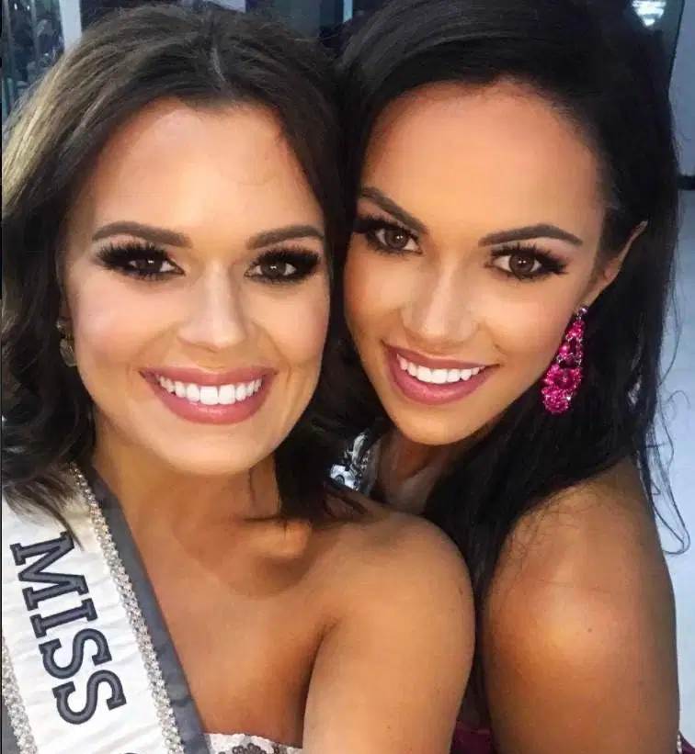

“it has to be,” I said. “But how am I going to go to school, or even walk outside, looking like this?” I drew my thick long hair, curled at the ends over my shoulder. It was undeniably gorgeous, but it did not belong on a guy.

“You can do home studies,” Mom said. “As for going out, you can do it as Candace. You can live as my beautiful daughter for a while.”

So, It could not go out, but I could call Gemma and ask her to come around. When she saw me, she was amazed, and maybe even a little jealous. She was good-looking, but nobody could deny that I was a better-looking girl that she was.

“Your face is just so beautiful,” she said, running her nose all over it, and kissing me like she never had before. “I would love to go to bed with you.”

It sounded as if I was at last going to get what I wanted. I arranged to meet her at my uncle’s vacant house where there was privacy and a bed. She asked me to wear a nightie and panties. It seemed like a strange request, but honestly if she had asked me to wear a chicken suit, I would have done it.

She arrived and I was dressed as instructed, with my hair around my shoulders and a little makeup on. She quickly shed her outer layer, and she was wearing sexy underwear. My cock sprang to attention.

She looked at it straining my panties with some disapproval, then produced from her bag a strap on dildo.

“For girl on girl, penetration needs to be two-way,” she said. “If you plug me, I need to plug you.”

I have to say, those words and the sight of that apparatus made me flinch. I was not ready to take anything up my ass, even though I was keen to get into her. She had played me along. I did not even ask who she proposed would be first. The last time I had more or less resolved to break with her. Now it seemed more than ever, that she was never going to let me fuck her.

“I’m not doing that,” I said. And that was that. It was over between us.

Somehow, that decision was liberating. I was free to just be Celeste, and to spend time with my mother as her daughter. My father told me privately that he had never seen her happier. We just went shopping together, she showed me her wardrobe of old beauty queen outfits that she could modify, and she even showed me how to sew. And I helped her in the kitchen as I never had before. My father thought it was a great joke, and he and my brothers referred to us as “the Ladies”. It would be hard to think of me as anything else, with my long dark hair and my smooth face.

It seemed like all of this helped me to become more of a woman. It certainly pleased my mother to have a daughter around, even though I think we both thought it would only be temporary.

After all, there was just the one contest and then it would be over. And before we knew it, it was upon us, and I was in the dressing room, preparing with all the other girls, even though I was not one.

We had already gone through some of the preliminary rounds when I got the call. The contest proper had yet to start, but in those rounds I had been noticed by a scout for one of the world’s largest model agencies – I think you might know the one.

“Whether or not you win, you have the shape and the looking that we have a market for,” the lady said to me. I turned to my mother in shock as she was taking pictures of the dressing room activity.

I was trapped. But looking back, that moment, and winning the crown, and making my family proud and with a bright future before me, it was the best day of my life.

The End

© Maryanne Peters 2020

