Bridal Choices
A Short Story
By Maryanne Peter

I now understand why it happened. I have been a fool all my life. I imagined a life for myself that was dictated by the shape of my body, not the shape of my soul. I now know how wrong I was.

I loved the idea of a wedding. The flowers, the vows, the confetti, but most of all, the bride. How beautiful she would be, as I stood there beside her. Everything about her would need to be perfect – the dress, the hair, the makeup, the posy. I had a clear image in my mid long before I even had a girlfriend. That is just not normal thinking for a guy.

I wanted Eloise to be that kind of bride. It was men who persuaded her bridesmaid to pretend to be sick so that I could help choose the dress. I made a show of being reluctant, and maybe I was, a little, because I knew I was too invested in it. I could not believe what Eloise was thinking. Her ideas were awful. Either slutty or frumpy, and nothing in between. It was almost as if she wasn’t interested. Or at least, not as interested as I was.

The woman in the bridal shop realized that I had a vision of what was needed. So when Eloise stormed off she made her crazy suggestion. She quickly assessed that I was the same size as Eloise, or would be with a little padding and corseting, so she suggested that I model the dress. We would then call Eloise back and present the total look to her.

The total look. Not just the dress. That meant next door for hair and makeup as well.

No man would agree to that. So why did I? As it was all being done, I imagined a whole series of explanations for my decision, but none of them was credible. Even now there is only one possible explanation: I wanted to be a bride. I have always wanted to be a bride.

I never said anything about that. How could I? That woman said something to me like: “Perhaps if you go through all that a bride needs to go through in order to be the best she can be on the day; you will have a better understanding.” It was like a lesson. I would suffer having my face and legs waxed, my waist squeezed and the flesh on my chest molded. But I had to keep secret the fact that this was like a dream coming true.

Then there was the hair. My hair was long enough and very full. It was fair, but for some reason I let them lighten it even more. It could then be drawn back and a complex updo fashioned with blonde hairpieces. It was the kind of thing the other part of the salon, the part next door, specialized in. In my corsetry and with all that was male on me pushed into oblivion, and just a peignoir robe, I was bustled through to hair and makeup.

But even then, I still thought of myself as a guy with some fixed ideas about how a bride should be. I would show Eloise and she would clap her hands and agree with me. She would be the bride and I would be the groom. We would be married. I would take her to bed, and we would live a normal life.

That did not happen.

With the dress I had chosen on, when I looked in the mirror I fell in love. I fell in love with myself. I realized that the old me was a repulsive creature. This person looking at me was something truly desirable. The perfect bride.  I somehow knew that Eloise would never achieve this standard. She could never be the woman for me. What woman could be? The woman I wanted was looking at me from the mirror.  “I can’t go through with it,” I said out loud.  “There is hope for me yet, then.”  I turned around and he was standing there. Tall and very good looking, with a voice like warm caramel sauce, and a look in his eyes that … well, a look spoke to me. | 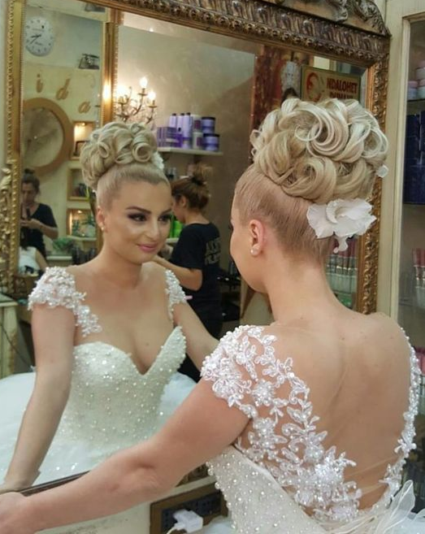

Is it possible? Is love at first sight really a thing? Can a person fall in fall in love twice in less than a minute? I had seen the perfect woman in the mirror. Perhaps my senses were already heightened by that vision. And then the perfect man appears. The perfect man meets the perfect woman. Surely there can only be one outcome? Except for one very unpleasant reality. But I was not thinking about that. Not then. Not in that moment.

I wanted to say something, but I realized that the voice that would come out of my pretty face would betray me as not being the woman in her bridal finery. I just smiled.

“I’m Nathan Boland,” he said extending his hand. “This is my mother’s bridal business.” He took my hand and rather than shaking it, he kissed it, as if I was a princess. Which is exactly how I felt.

I just smiled.

“I have come to take my mother for lunch,” he said. “But if you can’t go through with your wedding, then you may be available to join us?”

Should I speak? I had to say something. Could I do a woman’s voice. I cleared my throat putting my hand to my mouth in a fashion that was somehow automatically dainty and feminine.

“I am just trying a few things on,” I said. It came out well. A little husky maybe, but girly.

“But you may be considering whether this marriage is right for you?” he asked, with sincere interest.

“I think that I have decided that it is not,” I said, openly expressing the decision that I had just made. Eloise was not right for me, and clearly I was not right for Eloise. Not looking like this.

“In that case I insist that you join us for lunch,” he said. “If you are happy to have her join us, Mother?”

He was looking over my shoulder, so I turned to see the elegant older woman he was addressing. She was not one of the people who had lured me into this costume. She must also assume that I am female. Nobody else came forward to explain. Everybody in the place seemed busy.

“I just came in a track suit,” I said. “I don’t have anything to wear.”

“Nonsense, my Dear,” said the older woman. “We have something in your size. We might remove that decoration from your hair, which looks wonderful, I should say. And are …?”

Jim. I could not say that. “Jessica,” I said. Suddenly I had become Jessica.

I accepted the loan of the beautiful blouse and skirt, and the shoes, and I went to lunch with Nathan Boland and his mother. I could recount everything that happened, but I can only say that it was a whirl. It almost seemed like an outer body experience. Certainly, everything that happened was on another level. A level somewhere between earth a heaven. Somewhere perfect, where every word that he spoke was music and every look that he gave me thrilled me beyond belief. And where it seemed that I was having the same effect on me.

Before lunch was even over, his mother said: “I am going to leave you two to finish on your own. I feel like an intruder.”

We both protested out of politeness, but really, we had reached the point where conversation was for us, unnecessary. All that we needed to do was to look into one another’s eyes – to swim in each other’s soul pool.

After lunch we kissed. He started by kissing the nape of my neck under my glorious hairstyle as they processed hi payment of the check, but when we got outside, he took me in his arms and I just melted. If I had thought that I was meant to be a woman when I saw my reflection in that bridal dress, in his arms I knew that it was true.

But he thought I was a woman. I was. I just needed to put it right.

We got back to his mother’s bridal shop. I was hanging off his arm and laughing at something he was saying. And there was Eloise. She was back and she was trying on some stuff. Not the dress I had been wearing. Something tacky and awful. She really did have the most appalling taste.

She had no idea that it was me. Not at first.

One of the women attending her said: “It’s a pity that you did not see your fiancée in that dress earlier. Such a good choice. But look at the hairstyle we did. We could do something like that for you.”

The slow realization would have been amusing at any other time, in any other circumstance. But now it was just terrifying.

“You were engaged to another woman?” Nathan asked in disbelief.

“Were engaged?” said Eloise in equal incredulity.

“It’s over Eloise,” I said to her, in my vastly improved feminine voice. And to Nathan I said: “Even if you could never want me after you know everything about me, I want you to know that it was over with her before I even met you, and then … and then … if such a thing could happen so quickly … I am in love with you. I want to be with you … forever.”

He took hold of me by my arms and looked me squarely in the face. What a man he was. Perfect. Strong. Dominating. He said: “I don’t care about your sexuality in the past, I want you too. I love you too.”

“You have to be kidding me,” said Eloise. “Your new girlfriend is a …”.

But my sexuality was in the past. Nathan was true to his word. I was true to mine. Love is between two human beings. He is a heterosexual man. I was one too. I was.

I got to wear that bridal dress after all.

The End

© Maryanne Peters 2019

Author’s Note: This was Lisa’s suggestion that inspired this story: A man's fiancee had arranged bridal shopping for a gown but her best friend is sick last minute. He is made to go with her instead even though it is bad luck to see the bride! She tries on many dresses, but he doesn't like any of them and she is insulted. They argue and she leaves for a drink to be back later. The salon owner has a novel idea: Dress him up as a bride as a joke to make the couple back together, as this would show he loves her and spending time as a bride will show empathy for her. He reluctantly agrees, but the look is not right without makeup and wig, which the salon next door provides, and of course a corset and the right lingerie to give him shape! He is actually very pretty so tries on dresses. In the meantime, the salon owner's son visits for lunch and is entranced by this beauty. It is like fate, as neither man was gay but it was love at first sight. Our 'girl', Jessica, formerly Jim, is changed into a nice blouse and skirt so the new couple can go out for lunch and get acquainted. They return arm in arm an hour later to see a fuming ex gf still trying on dresses. She is shocked to see her ex bf is now a pretty woman and has a boyfriend!

