Forensic Accountant

Inspired by a Captioned Image
By Maryanne Peters

Gabrielle looked up at her prospective employer as he walked up and she knew before he sat down that she'd have to answer the question she could see on his face. Her company was still listed as Gabe Wilson forensic accountant. Just about every new employer she's met since she stopped switching back to Gabe after a job would ask lt or at the very least want to know who she was. Before Frank Johnson could say a word she said, yes I'm Gabe Wilson or at least I used to be. This used to be my disguise when I went to work at a client's business. I've become so comfortable as Gabrielle that when I'd switch back to Gabe it felt like that was the disguise. Now I'm Gabrielle all the time. Now as to why? If you were the CFO of a company you were embezzling from and cooking the books would you have any doubts about me being able to find anything in an audit? Frank chuckled as he shook his head saying I'm sorry but you look too pretty to be that sharp. Exactly, Gabrielle said with a laugh. The dumb blonde book keeper probably can't add 2 and 2 without a calculator. I've gotten far more heip from the very guilty parties than they knew they were giving just flashing some cleavage and a little leg. So when are you ready for me to start? I've just got to wrap things up with a report on the current job and file some copies with the DA and I'm done. I'II have to insist you sign this agreement as she pulled it from her purse. It prohibits you from revealing this identity to anyone. Frank asked as he signed could I take you out to dinner sometime? Gabrielle smiled as she said maybe after the job is done. He's handsome and I almost knew he was going to ask.
The first time that I tried I was not trying to look pretty. Book keepers are not always the prettiest girls. The most important thing is to look like a girl. I had a blunt shoulder length bob wig, with bangs, and glasses in my prescription that were heavy framed. I wore lipstick and eye makeup, a long-sleeved blouse up to the neck, and a skirt down below the knees, with pantyhose and sensible heels. The lady book keeper's uniform.

I refined the look over time, with the purpose of eliminating suspicion. A good (undercover) forensic accountant must be able to join the staff of the target business but not make the criminal feel at all uncomfortable. I quickly understood that most men (and they were invariably men) believe that the prettier you are, the dumber you are. Or, at the very least the pretty ones can be manipulated by the force of masculine dominance.

Embezzlers are wary of plain bookkeepers. Perhaps they think that they are bitter and therefore cynical and skeptical. Somehow if you are pretty and act trusting of these men, they not only accept you but open up to you. If you are pretty.

So, I decided to take some radical steps to make my disguise truly effective. That meant growing my hair (and adding extensions) and having some minor procedures to change the shape and appearance of my face. Then, later, more radical procedures to change the shape of my body. And drugs too.

It meant that the disguise could not be shed as before. Sure, I could take the dress or skirt off when I got home, but I still had breasts so I still needed to wear a bra. If I went out at night between jobs, I suppose that I could be Gabe Wilson, a guy with long hair and tits? I don't think so. It was just easier to be Gabrielle.
But the truth is that I did not go out that often between jobs, because there was really no time. I would barely have time to file my report before the next job, and when you are constatntly undercover any kind of life outside the work would just get in the way.

When I did go out it would either be to socialize with the accounting team and pick up leads, or to work on the mark - the target of my investigation.

Looking as I now did, I would get the invitation, and after a show of resistance I would agree to a dinner date, or any opportunities to get him relaxed and off his guard. Sometimes, I would go to the ultimate. I don't mean that, because I keep myself safe by being fully prepared. I have a stash of a well known "date rape drug" which I can sneak into his drink if I am invited to second base. If I can't get the juice that evening I would jack him off while he slept and I would spend most of the following day hinting at the great sex we had last night.

That is how far I go to do my job. That is how committed I am. If I have to stroke his cock and then stroke his ego to get the leads I need. Then the real work begins. Once you have the leads it is just old fashioned accounting that will bring in the hard evidence. Do the numbers, add and subtract, complete the renconcilations. It is not all glamor.

And then I was engaged by Johnson Industries. They knew things were not right, but they had a big accounting team and had no idea what was going on. So I was called in to meet Frank Johnson, President and CEO of the family business.

I introduced myself as Gabrielle, but it led to a question I get now and again: "So if the business is Gabe Wilson, then who are you? His sister? Don't tell me you are his wife? That would be very bad news."

"I'm Gabe Wilson, or at least I used to be," I explained. "This used to be my disguise when I went to work at a client's business undercover. But I've become so comfortable as Gabrielle …".

He looked a little shocked, or maybe dissappointed, but he was also intrigued. He told me that he was aware that I had a serious record of success. After our discussion on my methods he commended me on my approach. He signed the engagement letter and I agreed to start the following Monday.

It did not escape my attention that Frank had taken the time to have a close look at my body. I think most women would be conscious of it, but because I am not a woman, I definitely was. In some way it can be treated as a compliment on my disguise, but it can still be unsettling.

I started on Monday as the new junior accountant Jenna Kelly. Like most juniors I was put on bank reconciliation, which is always a good place to start looking for skimming. The problem was that too many people had the access to records needed to conceal theft. Way too many people, even considering a business on this scale.

The two most likely targets were both typical in their way. Gareth was a quiet bookish type, but was easy prey to my charms when I used the "little-girl-lost" approach. His hunger to impress me made me think that he might be the kind of man who would have appetites that might need money to satisfy.

Manuel was far more self-assured and fell for my "vamp-behind-the-glasses" line. There was no doubt that he was the kind of status-driven macho guy who could easily draw from the business. He was harder for me to control, so I needed to take care not to be too close to the stationery room when he was on the prowl.

But neither had any direct links to the money that appeared to be disappearing. What was needed was a meticulous approach to payment of regular invoices at a figure that was small enough not to draw attention but large enough to accumulate to a number wort stealing. It would take time.

Even I need the opportunity to relax a little, and it would not be with either Gareth or Manuel.

Frank surprised me by inviting me out to dinner. He knew who, or rather what, I was, but he said that I should treat it as a date. We would not be talking business. It would be a true release from the pressures of work for both of us.

I decided to go all out. I went to a salon after work and had my hair put up with curls on top. I bought a new dress with plenty of cleavage on view. I wore contacts. I have to say it - I looked spectacular. Frank thought so too.

We talked and we ate, and we drank and we laughed. And I realized that this was what was missing in my life. For the sake of my work I had sacrificed any meaningful social life. I was stuck in a disguise that I had carefully constructed to be a successful forensic accountant, but at the cost of being a man who could lead the life of a man. Somewhere along the way I would need to make a decision as to when this would end.

But in the meantime, Frank took me out again, and again. Not just to restaurants in town, but weekends away.

"I am almost ready to say that I don't want you to find the embezzler," he said. "I just like having you around, looking for him."

But I am too good not to produce a result. I got to the bottom of it eventually. Rather than file a full report, I decided to tell Frank over dinner.

To my surprise he took what I told him very calmly. He even smiled as I stared at him.
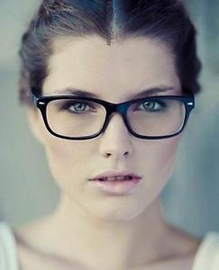
"It's a family business but most of the family do not care about it," he said. "Only I care and I do not get rewarded for it. What goes missing has no impact on the business but might allow the person taking it to live a slightly better life, and provide comfort and pleasure to those that he cares about."

"So you are admitting it?" I said. "You are the embezzler."
"Well," said Frank, "Do you really care if I am going to share it with you?"

"What do you mean?"

Frank dropped to one knee. He took my hand and looked up at me. He said: "Gabrielle Wilson, putting to one side for a moment what I would regard as a surgical imperative, but based upon my genuine and total love for you, and in the hope that you might feel just a fraction of what I feel for you, would you consent to be my wife?"

It is not the kind of proposal that any man expects to receive. But the accountant in me persuaded me to at the very least, consider a cost benefit analysis.

Benefit number one: Well, provided that he desists from criminal behavior here is a man of ability as well as his obvious wealth. If he was to resign his unpaid position the independent board would need to pay three times as much for somebody at the same level, I had seen that by now. He could be hired back or live of the handsome dividends like the rest of his family.

Benefit number two: Here is a person who shares much of the same interests as me. We both love the cut and thrust of commerce, but also the finer things in life - food, wine, music and travel. It was hard to think of anyone that I had ever met who was such a match.

Benefit number three: Love. Here he was on one knee. And what was going on in my body did not seem to be coming from my cerebrum at all. Whether it was the heart or the belly, I was all aflutter. What is that if it is not love? Whatever I was before, I was now in love with a man.

Cost number one: Those male organs will need to go, and be replaced with something more aposite to the rest of my body. Was that really such a high price? Are there any other costs? None I could think of.

"Mr. Johnson," I said, "you have yourself a bride."

The End

© Maryanne Peters 2019

Besties

Inspired by one of Knights Captioned Images
By Maryanne Peters
Mikki checked her hose as she waited for her room mate Lonnette to bring her the skirt she was going to borrow. A few years ago when she was still Mike she had the hots for Lonnette's sister Shelly. She had no idea that Shelly liked turning boys into girls. She'd done so to Lonny and she did one of his friends until his parents moved away. She got Mike to dress up with Lonny with a promise of wild times later if he did. He didn't find out the wild times wouldn't be with her until Shelly's boyfriend showed up with two of his boys who had been there before. They all had that thug look and were big buff brothas. Mike was scared of them and soon found out he should have been. He was soon in Deshaun's arms being kissed and felt up like a girl as he watched his friend start to give Jamal a blow job. He'd never seen a cock that size and the whole situation had him confused but turned on. By the time he found himself on his knees next to his moaning friend he had no resistance left, and found his head being guided by Deshaun onto his cock. It was a blur of activity after that but Shelly's words haunted him all the way home dressed once again in boys clothes that now didn't feel right next to his hair-less smooth skin. She said you're a girl, a sissy girl Mikki, no real boy would have done what you did. It wasn't long before he was back at Lonny's house to do it again. She and Lonnette have their own place now and live as girls full time. They're both taking hormones and one day may get the operation but it makes no difference to the guys they go out with. Shelly and Marcus left town but Jamal and Deshaun still come around and sometimes bring friends

I thought that it was just me when Shelly had me dressing and acting like a girl. I was not really "one of the boys" so Shelly suggested that we could do things together, if I was ready to become her sister. I suppose that there was a longing to overcome my shyness, and dressing as a girl just seemed to fit. I was unrecognizable as me, so I could become somebody else. So, I did. I became Lonette. Somewhere along the line Alonzo (people used to call me Lonny) just died.

If I had one friend in the world it was Jason. He was shy like me, so we just hung together playing video games.

"Jason can join us," Shelly said. "He can become Janelle." So, I guess he just followed me along for the ride. But Shelly was at the wheel.

It all seemed quite harmless. Mom just laughed about it, and Dad, well, I haven't seen him for years.

Nobody notices guys like Jason and me. Nobody notices that our hair is too long and our bodies are shaved or plucked. We were just a pair of shy little guys who became girls when we got home. At least we were girls when we got to our place and Shelly did what she loves to do. She just has a thing about changing guys into girls.

She says that hair and makeup are her thing, and she loves a challenge, but we knew it was deeper than that. It is like she has a thing for big black guys, and she thinks that is the only kind of man a girl should be with. She never says it to us, but it is like she thinks small guys like us are not real guys at all. Maybe she figures that we are girls on the inside, or something. She was always talking about bringing out the woman inside us.

I think that it worked for Janelle. Before I knew it, she was saying that she did not want to dress as a guy anymore. She wanted to go full time as a girl. She came around one morning, and Shelly dressed her up in a dress and a high ponytail with a ribbon, and off she went to school.

The place went right off. The principal called her parents and they came around. I was there waiting with Janelle as a friend, but still Lonny. His folks walked in and the shit hit the fan. They had never seen Janelle as Janelle before. His Dad started shouting and his Mom started crying, and Janelle just sat there and said: "This is who I am". I never knew either.

So, Janelle moved away, and it was years until I saw her again.

Shelly said that Janelle was "her best work". She was casting around for somebody else. And then she found Mike.

Mike was not so scrawny but he was not a big guy. He was not shy either. He was chasing Shelly. It was crazy really, as she was with Marcus, the captain of the basketball team. But Mike was persistent.

"Don't you think he would make a pretty girl, Lonette?" she asked me. To be honest he still seemed manly enough so that I did not think it necessary to warn him of what kind of person Shelly was.

But that kind of desire makes a man do strange things. She led him on and made all kinds of promises, I suppose. She brought him home after school and showed him how she transformed me. He thought it was funny until she said: "Your turn".

I am not sure if she ever let his get very far, although I don't think she was 100% loyal to Marcus. Anyway, she kept grooming him, and me. That included compulsory "girlshakes", some pink smoothie which we now know was laced with feminizing chemicals.

Mikes hair was long but curly. When Shelly used the straighteners on it, it was shoulder length. Mine was even longer. I think I looked pretty good as a girl, but Shelly was right, Mikki looked gorgeous.

I think she took a photo and it got to Marcus, and maybe got passed around from there. Anyway, Shelly decided that it was time for us to go that little bit further.

Mom was away for the weekend. Mikki and I were dressing up and walking around in Mom's high heels when Marcus came to the door. He had with him two huge guys from his team: Deshaun and Jamal. She had asked them to come over, to take us that little bit further.

Jamal was massive. I mean he was a big guy, but when he was naked, he was massive, and he got naked pretty quickly. I mean, where did he hide that thing. It did not seem possible, and when he told me to put it in my mouth, that seemed unachievable. He just laughed at the look on my face. We can both laugh about that now, my first time.

I looked across at Mikki and Deshaun was cuddling and kissing him, as he watched Marcus doing the same to Shelly. It was clear that he understood. He was not scared like I was, just shattered knowing that Shelly would never be his, and that she did not care what would happen to him.

I heard Deshaun say: "Don't worry about her, Pretty Baby, I promise I will take to heaven tonight". There was a gentleness in his voice that I think Mikki picked up on as he leaned into the embrace. It was as if in that moment of feeling crestfallen and betrayed, any arms around you feel good.

Contrast that with my position. Jamal had just stripped down and shoved his cock in my mouth. I didn't get hugs until afterwards, but by then, or soon after, I knew that his feelings were genuine. He said it was the best blowjob he had ever had, but only because my mouth was so small I was just working the tip of his penis. I didn't know how to blow a guy. I am not sure that I do now.

But now after months of dilation I can take Jamal inside and with my feet above my head I can watch his face in his moment of joy. That is my joy.

Janelle says I should get bottom surgery like she has. Mikki is a starter too. We are all the same, you see. T-girls. Besties.

The End

© Maryanne Peters 2020

The Convention

Inspired by one of Knight's Captioned Images
By Maryanne Peters

Donna was pushing at Daria as the two looked back at Calvin who'd just made a comment about how cute Daria's little sister is. They were on the way to their booth at the convention center and Calvin works for the center as part of the crew. Donna wanted her to move faster because she didn't like the way Calvin was looking at her it made her feel funny inside and she wasn't sure why. Daria thought it was cute that the usually shy Calvin was so taken with her little sister. She wonders if he'd be so interested if he knew that Donna is really her little brother Dewayne. She'll have one more thing to tease him about all day as they work their booth. When she told their mom that Dewayne could get a job at the convention and Ann agreed Dewayne thought he'd be working as part of the crew that helps set up display booths and other stuff. Daria has done him up lots of times as a girl when the two are home alone. She knows he can pull it off. When she told Ann how much they would pay she went along with the idea. She knew they'd never hire little Dewayne to do any heavy lifting anyway. The extra money will be a real help to make ends meet. Daria knew that her brother really liked being Donna, he just complained because he thought he should, if the look on his face when she was done with him is any indication she'll have her sister to help her from now on. She's sure they'll offer Donna a job for week ends and all summer like they did her. Looks like she will finally have the little sister she's always wanted.
I did not have an older brother to admire and emulate. I had an older sister. It seemed to me that Daria had it all. She was smart, talented and good looking. I was nothing. "Li'l Dwayne" they called me. Little Dwayne - small and weak.

My sister made a lot of her own clothes. She also styled her own hair and was an expert with makeup. She was outgoing and confident. I was the opposite.

People thought I was gay, but I was not sure. I always thought that I would love women. After all, I worshipped my sister. She always seemed to look fantastic. But others might have though me effeminate. It did not help that I had quite long hair. It was just there to hid behind.

Sometimes my sister would ask me to wear a dress of hers so she could remodel it. I am smaller than her, and with no shape, so the only way I could function as a dressmaker's dummy was with some padding that she had made for me. When I was wearing it she liked to call me Donna. She wasn't teasing me. We shared the joke.

Daria got a part-time job at the Convention Center not far from where we lived. She quickly became indispensable, as only she could. She manned the welcome booth and sometimes she designed and modelled a costume following the theme of the conference. She was a natural. Everybody loved her.

I told her that I would do anything to get some part-time work, to get enough money to buy a high performance gaming PC. There was nothing going. I talked to Daria about getting work at the Convention Center and she said that she would look for me.

I was complaining as I was modelling an outfit for a big conference while she was pinning some detail to it. It was a two-piece outfit with the pants in metallic red and white, so tight that it pushed my junk almost back inside me. The detail was a rigid flare around the waist.

"I have made a mistake and cut this too small," she said. "Now you are the only person who can wear it …".

She stopped and looked at me, strangely. She said, "This is going to be a big conference, the one this outfit is for. Mine is a two-person job. We could do it together".

"I thought they only have female staff on the welcome booth," I said. It seemed sexist, but I guess this is the world we live in.

"That's right," she said. "That's right, Donna."

She called me Donna. I knew what she was thinking. It seemed crazy, but she was insistent. I cannot refuse her. I never have been able to. She told me that she could transform me, and I never doubted it. It seems that there is nothing that she cannot do. My real concern was that I would be so useless in pretending to be female that I would embarrass her. She told me that had total confidence in me, and I guess that drove me to do the very best that I could.

I used the padding and the outfit that she had me try on, while she made a larger one to match. She has a proper butt, but mine still looked good. I just needed to shave my body where I had any hair that might show.

She then set about giving me a hairstyle to match hers. I had enough hair to pull back with height on top, adding a false bun at the crown. Then she applied makeup. It would be exactly the same makeup that she would wear on the day I went with her to the convention. We looked almost like twins. How could I not feel good about that?

But the most remarkable thing was not how good I looked, how I was able to hide all all trace of maleness in an outfit that skimpy, and how well I was able to follow her cues and appear entirely female. No, the thing was that being Donna seemed to change my personality completely. Or maybe it was the costume. There was no hiding in that get-up. I was not just feminine, I was sassy and sexy.

Maybe there was still a hint of shyness in me that drew Calvin to me. Daria said that he was an introvert, just like Li'l Dewayne. It sure did take him ages to get up the courage to ask me out. If I had not seen in him the guy I might have been, I would never have agreed to go on that first date. I was just thinking how devastating it would be if I was in his shoes and the pretty girl said no.

It even made it easier for me to tell him that I was not really a girl at all, on the third date. But by then we understood one another. We were so similar in many ways, and I am not referring to our sex organs. They are not the same anymore - not now anyway.

The End

© Maryanne Peters 2020

Temping  Inspired by this Captioned Image  By Maryanne Peters  Mom said that the agency only handled women. It was part of some “affirmative action” thing – in particular, they were looking for women to expand into jobs that were not normally done by women – have a temp fill the role and prove something.  She complained that computer systems work was an area that was dominated by men.  “If I had the right candidate, I could slot them into a spot that would earn big money,” she said.  The job that she was describing was just the kind of stuff I did for fun, and I really needed the money to be able to buy that car from down the street.  “Can’t you make an exception and get me that contract?” I pleaded with her.  “No exceptions. I only contract out women. So unless you want to be a girl, no dice.” | 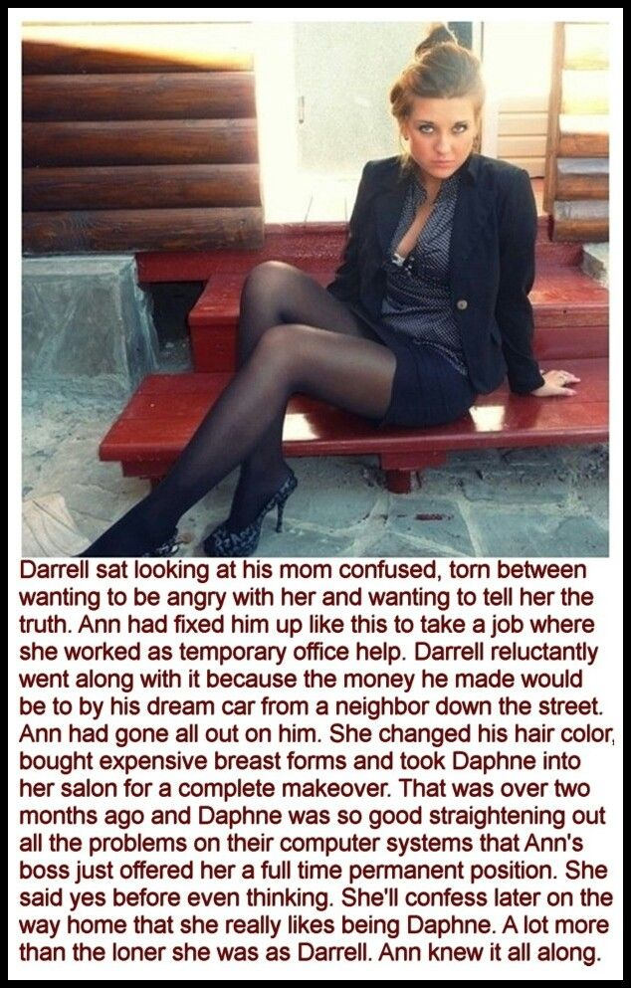

But then she looked at me, strangely. She said: “Well we might be able to but that long thick hair of yours to some use. But I am telling you, that if you are not going to do this properly, you will get me into serious trouble by referring you to the agency.”

“Mom, don’t worry. I know computing back to front.”

“That is not what I am worried about, Darrell,” she said. “It will be in passing yourself of as female.”

My jaw must have dropped to the floor because she just laughed. “It won’t happen otherwise,” she said. I am not going to have my company employ you directly. If you want this job, you have to go through them. And to go through them you have to be a woman. But I think you could get away with it.”

“Come on, Mom! No way!” It was male pride that made me say it. But I was not a big guy and certainly not manly looking. She was sizing me up. I was thinking about the car. I was thinking about what I was prepared to do to get the money to buy it. “Do you really think I could do it?”

All that I had to do was to do exactly what she said. The agency was important to her, and I understood that she was breaking the rules to get me work. It was important that I not let her down. That means looking and acting like a woman.

“We are going to have to get you proper breasts,” she said. You have a little flesh from a late puberty up there, and with good forms we may even be able to work a cleavage. That will help. And I will need to book you a full body wax … and hair coloring. Mousy is not good enough for a professional woman. Unlike men, an untidy appearance can mean sloppy work standards. Unfair, but reality. And voice coaching to lift the octave and improve elocution …”.

It was all sounding way too much, but when she told me how much the contract was worth, I was ready to lie down and grit my teeth as the body hair came off, and sit in the styling chair for three hours for the treatment, coloring and straightening.

“Your mother tells me that you are Daphne from now on,” the colorist said. “What a beautiful name. And what beautiful hair. You can wear it down around your shoulders but for work I recommend that you wear it up in a loose bun. Let me show you how. And we will have to get those ears pierced.”

I was ready for it, to keep things safe for Mom, and for me too. Nobody wants to walk around town pretending to be a girl when everybody is looking at you and thinking: ‘Hey, that’s a guy!’

“You have such great legs,” Mom said. “A girl with legs like your would never hide them. We need to get you some short dresses and skirts, and some nice tights, and shoes with a bit of a heel.”

“Mom, I am a computer programmer, not a runway model!” But she was in charge. I had agreed to follow her instructions, and that was what I was going to do.

When I was ready, I set off for the agency wearing my short skirt and heels, and introduced myself as Daphne. I had renamed some code on my Github profiles and they asked me to do an exercise rather than present a CV. They knew their stuff. I aced it in less than 15 minutes.

And the following day I was presenting myself to Mom’s boss as her niece Daphne – He knew that she only had a son at home. But I had won the job through the agency.

The photo she took of me in my velvet suit was about a week or two after I started. It was a Friday and I planned to go out with some of my co-workers once the day was done. She said that I looked so good in that outfit that she just had to take my picture. I could not resist that look. I had actually done my own makeup that day. By then I was quite good at it. Plenty of eyeliner but understated lipstick colors and clear nail polish. It is good for a day night look, just in case after work drinks turn into something more.

Well, looking like that, they did.

I had all the guys at work hitting on me. I suppose I should not have, but I really started to enjoy it. I mean, I was a long hair computer nerd, and now suddenly I was the center of attention. I wanted to agree to everything but I am not that stu[id. They were buying but I had to watch how much I was drinking, and I had to turn away the guys who were getting to close.

The problem is that in a crowded bar when somebody is squeezing your tits and you do nothing, they think you are approving. That is the problem with breast forms. The expensive ones feel like the real thing to them, but I feel nothing.

His name was Rafe and he was into me – or should I say Daphne - in a big way. He just would not let me be. When I told him that I was ready to leave he offered to get me a cab. Out on the street he was trying to grope me. It was then that he said had been tickling my tits all night.

I waited until the cab pulled up before I gave him the bad news.

“They’re false,” I said. “Latex and silicone breast forms stuck on my flat male chest. I am false.”

For some reason I started to cry. Maybe it was the look on his face. He was shocked. He was not a bad guy. I quite liked him. But now he look desolate. I got into the cab and we sped away.

I told Mom that I could not go back to the job. I had been forced to give myself away to one of the guys at work, and now everybody would know.

“You could say you are trans,” she said. “I could be in trouble with the agency. Why don’t you do that? But you like this job. You have to go back.”

I could that this could be bad for her, so the following day I got dressed in something really feminine so that I could just ride out the abuse that I would get in style.

But nobody said anything. Everybody was just normal. Even Rafe just smiled at me and said “Good Morning” just like any other day. It was like he had forgotten overnight. Nobody knew.

Later in the day when I went to the mainframe room, Rafe stepped in and closed the door behind him.

“Thanks for not saying anything,” I said.

“I thought about this all last night,” he said. “Why would I tell anybody your secret. I think that I am falling for you, Daphne, because what you are hiding really doesn’t matter to me. I think that you are the most lovely woman I have ever met. We can work through your transition together. You need to be the woman you were meant to be.”

He had me in his arms. His face had a crazy look, like he was out of his mind, and it was down to me.

Have you ever looked into the face of somebody like that? I just had to kiss him. I just had to.

The End
Rams in Sheep’s Clothing  Inspired by a Captioned Image  By Maryanne Peters  Now let’s get this straight. The Golden Rams are a varsity team. The rules for women’s pro volleyball are very clear: Only women are eligible. That rules out Helen and Marsha, even though Henry and Mark are way behind them now.  The Golden Rams were set up when sport at West Chesley was still just for guys. Rams are male only right? Male sheep. And we are girls, or at least I am.  We always had guys busting in on girl’s teams, saying: “Move aside ladies. You need horns to be a ram”.  But there is no men’s volleyball team at West Chesley - the guys prefer contact sports. It was time to redress the imbalance. | 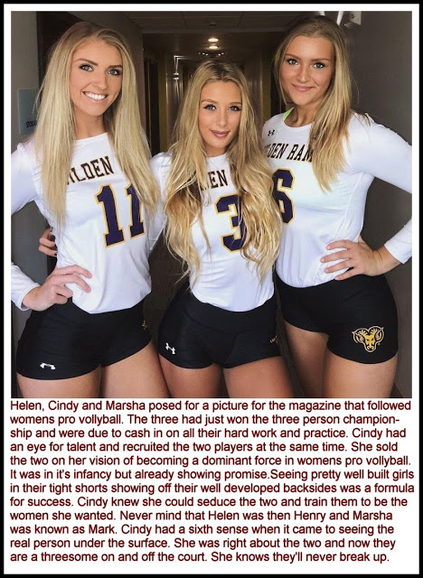

Henry and Mark were both from out of State and had played volleyball. They were not quite up to joining the Rams teams playing other sports, but they wanted to do what they liked, to play for the college, and to play at a competitive level. The chance to go pro beyond that had not even been discussed – they just wanted to play. And I wanted them on our team. We had serious weaknesses in our line-up. I wanted them so much that I slept with both of the to seal the deal.

“You are talking about us playing volleyball in drag?” they had both asked incredulously.

“Hell no,” I explained. “Not drag. We cannot tell anyone about this – not even our team. You have to play as women. That means becoming women. Living as women 24/7. Enrolling as women. Luckily when it comes to being a woman, I know all there is to know.”

We became a sexual threesome. It all seemed so much easier when we were all girls together with our shaved bodies and our blonde extensions, it was easy for Henry to think of Mark as Marsha and for Marsha to think of Henry as Helen. The only things that were out of place were those small dicklettes that seemed to become smaller throughout the training programme and strict diet I insisted on. We bought a new king sized bed which got plenty of use, and a strap on that we could all get to use.

I had only one condition – we are girls full time. Of course I am Cindy and I have been a girl all my life, but as Helen and Marsha are beginning to learn the pleasure of being female, somehow being a ram is less important than it once was.

The nd

© Maryanne Peters 2021

