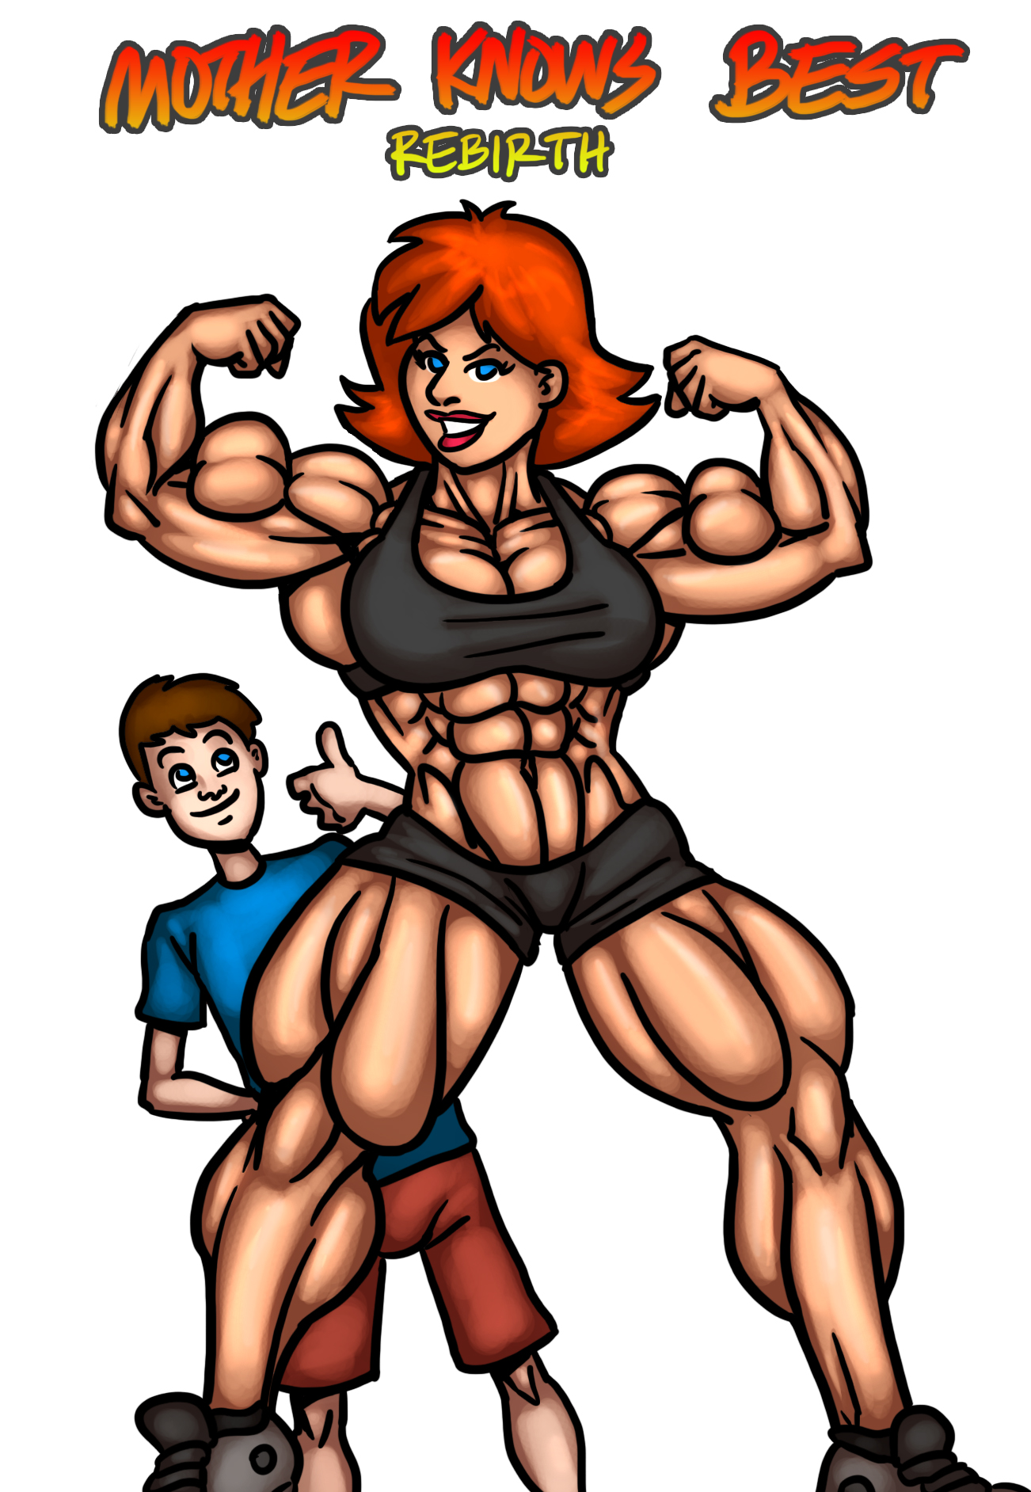
Mother Knows Best Rebirth Chapter 5 – Art Edition
by MagnusMagneto
Art by Ritualist
Special Thanks to Ritualist and Detritus2613
Approx. 9500 words

((If you are reading this, then it probably means you’ve supported me on Patreon or a site like SmashWords! If that’s the case, then thank you very much! It’s only thanks to your generosity that I’m able to spend so much time working on stories like this.

If you are reading this and you haven’t supported me, well, I hope that you enjoy the story regardless. If you like what you see, then please strongly consider dropping by my Patreon: http://www.patreon.com/magnusmagneto ))

(The Story So Far:

Tara, the 35 year old single mother of 17 year old Corydecided to spend the summer at her wealthy brother Terry’s summer vacation house. Cory was not amused by this decision, and opted to spend the first few weeks of their trip locked in his room, playing video games. Viewing the trip as an opportunity to change things in her life, Tara began to exercise and take better care of herself - yielding extremely speedy results. Encouraged by her progress, she attempted to coerce Cory into joining her in getting healthy. Instead of agreeing or even politely declining, Cory insulted his mother, and proclaimed that even after multiple weeks of training, he would still be stronger than her.

Tara took the challenge to heart, and pushed herself as much as possible. The results emerged fast and heavy, equating to a supernatural development of Tara’s body and mind. When it came time for the contest, she deftly defeated Cory in every possibly manner by a staggering margin, and began to implement new rules to try and turn his life around. While there was friction at first, after enough time, Cory came to appreciate his mother’s efforts, going so far as to encourage her to become the best version of herself as possible.

Chapter 4 ended with Terry arriving at the house with his family, eager to catch up with his sister after years of having not seeing her. For Tara, this is an opportunity to show how much progress she has made since he saw her last - and to hopefully change her brother’s misogynistic views on women in general. )

1.) Immediately after the end of Chapter 4

Terry let himself in, quickly walking past Cory and into the entryway of what was legally his house. “So kid, what th' hell's new? Looks like ya grew a little since I last saw ya.”

Cory nodded. The last time they had met in person was years ago, when Cory was much closer to Terry's relatively short 5'6”. “I guess there have been a lot of changes between now and then.” he responded, holding back a bit of laughter as he thought about the immense transformation his mother undertook the past few months.

Terry failed to notice Cory's bemusement. “Looks like th' place has been cleaned well. Guess yer mom's done a good job of playin' maid, huh?”

Cory shrugged. “Honestly, I think I do more cleaning around here than she does. At least it's been that way for the past month.”

The older man cocked an eyebrow. “Really son?” he started, shaking his head, “You should just let yer old woman take care of that sorta business. Us men have more important things to do.”

“Like what?”

“Oh, just about anythin' really. Always remember that an hour of a man's time is worth far more than an hour of a woman's. Not to say you should ever do wrong to a woman, just to know th’ respective places of th' genders.”

Cory squinted his eyes. He was rendered fairly speechless. The statement uttered by Terry was ludicrous to him, insane even. At the beginning of the summer he may have high-fived his uncle, hoping that maybe he could crack open an under-aged beer with the man, but after the events of the past few weeks, sharing that sentiment seemed neigh impossible.

As Cory began to muster up a response, he was saved by a timely interruption. Tara's voice quick filled up the room: “Really brother? I had hoped by now you grew up a little and stopped following that puerile school of thought.”

Tara was standing tall and proud, wearing a classy sun-dress and specially fortified high-heels, which effectively displayed the immense muscular development that she had undergone over the summer. To say that Tara was muscular would be an understatement. Nearly 400 pounds of sheer muscle was densely packed onto her frame. Every ounce of it was expertly defined, straited, and displayed masterful vascularity. The dress was cut low, revealing the tremendous iron-plated slabs of pectoral muscle that sat underneath Tara’s hefty breasts. The garment was similarly short, showcasing the pillars of steely flesh that Tara stood on. Each quadricep possessed a thick, deep tear-drop in the center, the sides of which an average sized human could easily grip onto like a handle. Due to their immense girth, the bottom half of Tara’s upper thighs pressed against one another; yet a tiny gap could be seen at their zenith, further emphasizing the fact that the legs were pure muscle, with next to zero bodily fat adorning them.

Tara’s mere presence in the room was nearly overwhelming. Despite having grown more accustomed to it than any other person alive, Cory still felt himself affected by the intangible aura created from Tara’s immense power and confidence.

Terry burst out in laughter. “Who th’ frick are you!?” he spat out, doubled over. “What kinda elaborate joke is this? Hiring some crazy body building bitch ta take Tara’s place.”

The amazon placed her hands on her hips akimbo, which gave her an even more imposing presence as she took a few steps forward, her heels clicking loudly on the ground. “Really Terry? You should be able to recognize your own sister, even if she’s had a… bit of a transformation.” Tara said with a warm giggle.

Terry wiped tears from his eyes that had formed from the laughter. “No. Frickin. Way. TARAAAAA” he yelled out, “GET OUT HERE AND GREET YOUR BROTHER!”

Despite his cry, nobody came. The woman in front of him laughed warmly. “Come on Terry, you knew that I was having a bit of a transformation. We discussed this over the phone. I sent you my blood-work. You saw my changes. Well, the first batch at least. Remember?”

Terry blinked a couple of times. How could the being in front of him possibly be his younger sister? This was no mere woman, but something of a goddess. A statue brimming with strength, power, and femininity, all rolled into one. The heels Tara wore added even more height to her lofty frame, giving her a total height resting a full foot above Terry’s fairly short 5’6”. While Terry was a fairly thick, chubby individual, Tara’s body packed at least twice as much meat as his; though every ounce on the amazon’s body was pure muscle, aside from her prodigious mammaries. The result was a being of unbridled power that physically emasculated Terry in nearly every possible way, despite the almost exaggerated level of femininity Tara exuded.

“No, no no.” Terry said, shaking his head. “No way.”

“Why don’t you use one of your tools to test my DNA real quick? Or even a fingerprint scanner?” Tara suggested.

Squinting his eyes, Terry retrieved his smart phone, turned it on, and with a few deft jabs pulled up an app - one made by his own company. “Well, this thing isn’t one hundred percent accurate, but it should be close enough.” Terry started, “It records your fingerprints and uses a few other quick and dirty methods to pinpoint your identity, along with some other identifying marks.”

“Other identifying marks?”

The stout man nodded. “Pulse, heat signature, and some other fancy stuff to provide a simple bio-rhythmic signature. While I don’t have all of that stuff of yours recorded, I do have your prints.” He presented the device held screen up. “Just place four fingers, two from each hand onto it.”

Tara shrugged her brawny shoulders, causing a cascade of her lats and deltoids to ripple effortlessly, immediately sending a chill down Terry’s spine. She did as he requested, placing her large fingers on top of the device’s screen. After holding for a few moments, a beep indicated that the test was finished, and she was free to retract her hand. As Terry glanced down and read the results, a sweat broke out on his forehead. “Well.. I’ll be damned.” He murmured.

“Well? What did it say?” Tara inquired.

“I guess… it really is you. Though, it’s not a 100 percent match.”

“Oh?”

“For starters, while th’ fingerprint pattern is consistent, yer hands obviously grew a good deal to accommodate for, uh, well, all th’ other growth. There are slight mutations in yer DNA, although th’ baseline is so close that it HAS to be you. Also, when it reads yer estimated biological age…” Terry held up the phone; both Tara and her son looked at it. It read ‘31’.

Tara started laughing, while Cory simply stood there, bug-eyes. After a few moments, Tara finally spoke: “Really? Only 31? I feel a lot younger. To be honest, I have way more energy and focus than even when I was 21. Plus, you know, THESE!” Tara brought her prodigious arms up, initiating a double-bicep flex. The small mountains of muscle sprang to life, rippling to untold power.

“Well, I’ve got a quick an’ dirty theory for that.” Terry started, “Contrary to popular myth, more an’ more studies are pointing ta late 20s or early 30s as th’ real physical peak of a human being. Thing is, most people just sit on their posteriors up until that point, so they don’t get that progression. With that in mind, it wouldn’t be a stretch to say yer body’s actual physical peak would be 31 years old. Of course, that’s not what your real age is…”

Before the conversation could continue much further, the rest of Terry’s family abruptly entered through the door. In came four figures: Terry’s tall, beautiful, trophy wife, Estella; his average height, plump, 17 year old son, Barry; his small 10 year old son, Harry; and his 18 year old adopted daughter of Korean descent, Kiko.

As the family members entered, their eyes were all immediately drawn to the towering pillar of feminine muscle in the center of the room.

“Oh… My… GOD!” Estella yelled out.
“Th’ fuck is that!?” Barry exclaimed.
“Holy shoot! A superhero! Awesome!” Harry screamed.
“Weird.” Kiko murmured quietly.

1.5)

Estella was the first to run over toward Tara. An on and off supermodel standing at 6 feet tall barefoot, who almost always wore heels, Estella was accustomed to being the tallest and most beautiful woman in any room. Her body was lithe and sharply toned from years of pilates, yoga, and very light weight training. She was also a heavy user of the elliptical and stair-master cardio machines, but strayed away from running due to fear of the effects the constant pull of gravity could have on her perfectly shaped breasts.

“T-TARA!? IS that REALLY you?!” she exclaimed. The last time they had met, Estella stood taller than Tara; had larger breasts than Tara; held more muscle mass on her frame than Tara; was more beautiful than Tara; possessed less body-fat than Tara; was more confident than Tara; and, unknown to most, was actually more intelligent than Tara. Today however, every single one of those attributes had been reversed. Tara was the one who was superior to Estella in each category.

“Hey Estella. Of course it’s me. Though I’ve changed a bit.” Tara explained with a warm smile.

Without asking, Estella began grabbing onto Tara’s arms. “These muscles… they’re harder than anything I’ve ever felt in my life, and I’ve been with a few bodybuilders before - male ones…” she observed bemusedly as she continued to press and knead the various muscle groups on Tara’s arms.

Ten year old Harry was the next to approach the amazon. “Wowow!” he yelled out. “Is that really you aunt Tara?!”

The last time Tara had seen Harry, he was six years old. She was surprised that he remembered her. “You know it!”

Following his mother’s lead, Harry reached down and started grabbing onto Tara’s calf. “Mom’s right! This isn’t just a muscle, it’s like a super muscle!”

Estella continued her probing of Tara’s impressive form. "You... your skin... it's smoother than mine... and these arms! They're... they're huge! But in a good way! And your nails, so perfectly manicured! You complexion, so fair and even. Even your hair is like glistening silk. You simply MUST tell me your secrets! We have SO much catching up to do!”

It was all true. Despite spending relatively little time on skin and nail care the past few weeks, Tara had actually surpassed even Estella in this category, despite the constant professional care the latter underwent. Between her system absorbing the components of various creams, vitamins, amino acids, along with the various techniques she learned from textbooks, an undoctored photo of Tara would likely be called out as photoshopped.

“Wow wow wow!” Harry exclaimed. “What happened auntie? Did you get into a radiation accident that gave you super? Did you get stung by a super power granting bug? Did the government abduct you and turn you into a super soldier!?!?” He spouted off a few more nonsensical theories, as Tara’s transformation was simply too difficult for him to comprehend in any other fashion.

“Nope.” Tara replied warmly with a smile. “The truth is, I just worked really hard and put my mind to becoming the best me possible.”

“Whoa… how do I do that!? I want guns like yours!” Harry yelled out, playfully flexing his small, thin pre-pubescent arms to no avail.

“You want arms like these? Well, the first step is to start eating right, then hit the weights.” Tara explained before realizing that perhaps a 10 year old boy shouldn’t be pumping iron yet, “Well, maybe you should wait a couple years before the second part."

Estella and her son continued to prod Tara’s muscular body, exploring the various ridges, crevices and slabs that adorned each limb. While Tara enjoyed the attention, she could sense that with the rest of her extended family awkwardly watching nearby that she should try spurring things along. “Having fun? Say, who wants a ride?” Tara asked with a grin. Harry yelled out that he would love that, while Estella simply giggled with consent. Gently, Tara brought her arms down and grabbed onto both of their posteriors before hoisting them straight into the air. “Why, you guys are light as feathers!” she observed with a giggle.

After twirling Estella and Harry around for a few moments, she gently put them back on the ground and looked over to the other family members. “Barry, Kiko, how’s it going?” Tara asked.

Barry took a few steps closer towards Tara. “Is… is that, like, real?” He was a heavy-set teen whose doctor insisted he needed to lose at least thirty pounds, preferably more. The girth was packed onto a short frame similar to his father’s. His biological mother was Terry’s first wife, whom he married when he was young. Between the long hours Terry worked building his pharmaceutical business, and the first marriage’s divorce, Barry was primarily raised by various babysitters and daycares.

“Yup, you know it.” Tara answered with a smile.

Barry came closer. “No, like really, that isn’t a suit or something?”

Tara shook her head. “You saw me pick up your mother and brother. Wanna feel for yourself?” she offered before tensing a bicep, forcing to spring to life with unbridled vigor.

Apprehensively, Barry drew nearer and placed one of his hands on top of the limb, giving it the hardest squeeze he could muster — completely and utterly unable to dent the arm or make it budge at all. He quickly withdraw the hand before shouting “Gross!”

“Barry!” Estella yelled out, “Watch your manners!”. A few other murmurs were heard as everyone else reacted slightly differently to the outburst.

Surprisingly, Tara was the least visibly phased. The truth was, she actually expected him to react this way. Barry had always been extremely similar to his father in all of the worst ways, emulating his bad habits without gaining the man’s work ethic or ambition.

“Apologize to your aunt!” Estella demanded.

Barry shrugged. “Sorry. Just stating my opinion. Everyone knows that females aren’t supposed to have muscle, especially not THAT much. Hell, I don’t think ANYONE should have that much. That’s just unnatural.”

Tara’s hands were placed on her hips akimbo, granting her an even more impressive looking appearance. “I respect that you have your own tastes and opinions, but I assure you that I’m entirely natural, and have never been healthier in my life. Your father has scientific evidence to back that up.”

“Yeah, yeah whatever.” Barry said before shuffling away from the amazon, back towards his father.

There was one more family member for Tara to greet. “Hey there Kiko!” she cheerfully exclaimed.

Kiko stood transfixed for a moment. The young woman was, for the most part extremely quiet until she warmed up to situations and people. This was an attitude that stemmed from many different things: growing up without knowing her birth parents; inherited dispositions; Terry and Barry’s attitude towards women; the turbulent lifestyle of living in extreme wealth. Eventually she responded, “Hi.”

Tara knew that was likely all she would get out of Kiko from this interaction and didn’t press the issue.

-

Small, idle talk filled the room for a few moments before Estella made a suggestion: “How about we hit the pool? It was quite the ride getting up here, and I’m sure we could all use a nice cool down.” Secretly, Estella wanted to get a better look at Tara’s new body.

Barry and Terry were generally against the idea, Kiko was apathetic, but Tara, Estella, Cory, and Harry all thought it was a great idea. Terry’s family retreated to their RV to collect their belongings, set them up in the various guest rooms of the mansion, and prepared themselves for going out to the pool.

As everyone else readied themselves, Tara retreated to the basement's gym. Covertly, she began pumping her immense body up, lifting as much weight as she could without creating any noise. This method proved more difficult than Tara anticipated, as she had to focus on controlling the weight as much as possible in order to prevent any metallic clanging. She moved quickly, utilizing her known maxes for each workout, effectively challenging her body more than ever before due to the slow, deliberate motions.

After finishing her workout, she quickly toweled herself down and ingested two protein shakes full of as much powder as possible without making the beverage too viscous. The result of Tara's efforts was a body brought to a new height of muscularity courtesy of a menacing pump.

2.) A bit later, at the house’s pool.

Tara was intentionally the last to leave the house. She didn’t reveal her swimsuit clad body until everyone else was already outside. All eyes laid on her as she walked out of the house. Tara had selected an outrageous outfit: a white micro-bikini that only barely managed to cover her privates. Tara's immensely muscular body visibly swallowed most of the suit, giving the illusion that it was even skimpier. Every crevice of muscular development stood at attention without any effort, which in turn garnered the full of attention of those around her.

The goddess sauntered forward towards the pool, causing her abs to bunch up and ripple, while her thick tear-drop quadriceps shook ever so slightly. She stood by the edge and placed her hands on her hips, intentionally allowing her wide lats to spread outward. Estella, Harry, and Barry were all in the pool. Cory was outside talking to Kiko, while Terry lounged in a beach chair.

Stella ceased splashing around once she noticed Tara was nearby. She gazed upon the amazon, and even from a distance was thoroughly blown away by the sight in front of her. “Wow! Hot stuff, give us some flexes!” Estella yelled out.

Tara smiled and complied. First she struck a double bicep pose, causing her arms to predictably swell up to tremendous proportions. Next she turned her back to her admirers, performing an intentional lat spread, her thick back bulging outward. The amazon brought her arms up and tensed them, provoking her deltoids to bunch up, a starfish of striations adorning her cannonball-like shoulders. Tara raised her arms and lowered them a few times, allowing the audience to watch the ridges and chords of muscle in her back to dance. Next she squatted down and squeezed her glutes, causing her ham hock hamstrings to burst outward, and the hard innards of her bottom to group up, taking shape. Finally, Tara pumped her calves a few times, the immense diamonds of power springing to life with each repetition.

Even with her back turned to them, Tara could sense their emotions. She could taste Estella’s lust, Terry and Barry’s fear, Harry’s excitement, Cory’s admiration, and Kiko’s… Kiko’s mixture of feelings.

As if her body was a sentient being that understand the situation at hand, it began to quake and quiver as the protein ingested less than an hour ago funneled itself towards the muscles that had been worked. Right on cue, with everyone’s eyes on her, Tara’s body expanded, the muscles on her frame growing in real time. Roughly half an inch in circumference of sheer muscle appeared on top of Tara’s frame, materializing seemingly out of thin air. “Mmm, getting stronger all the time!” Tara declared triumphantly with a laugh. “I think it’s time to cool off.” She added before diving into the pool with a tremendous splash, causing a huge ripple of water to emerge from her point of entry, physically rocking the other inhabitants.

-

Meanwhile.

After seeing the underdeveloped, flabby forms of his uncle and Barry, Cory felt a bit better about himself. Sure, he looked anemic next to his mother, and truthfully, Estella's extremely toned form was probably harder than his own, but he was feeling pretty decent. The young man was inspired to continue improving himself. While he knew that achieving a physique comparable to his mother’s was likely an impossibility, there was no reason why he couldn’t have a nice, strong body that he was proud of.

Having gotten a lay of the land, and with things settling down, Cory attempted to initiate conversation with Kiko. She was still wearing a baggy sweatshirt and pants, despite the temperature and location.

“Oh, um.. Hey there Kiko.” Cory turned a shade pink. It was an involuntary reaction. Cory normally wasn’t too shy around girls, but he couldn’t help himself in this instance.

The last time he saw her was half a decade ago, before either of them had finished with puberty. Kiko looked like an entirely new person, and time had treated her extremely well. The girl was, in a word: beautiful. She wore fairly minimal makeup, only a small hint of mascara and eyeliner to accent her natural features. Her long, silky black hair was done stylishly, and her moderately long nails were painted black.

“Cory.” She replied.

Cory blinked a couple of times. He had hoped she would give him more to work off of than just that. “So… that’s a nice pool, huh?”

“Yeah. Guess you didn’t use it much this summer?”

“Wh-what?”

Kiko’s expression changed to slightly bemused as she continued: “Well, you’re pretty pale all things considered, and your shoulders are fairly undeveloped.”

Cory blinked some more. “Oh… yeah, I guess you’re right.”

Kiko shrugged, “Not trying to knock you or anything. Just stating some facts.”

“Right, yeah.” Even when she was younger Kiko was always this way: Fairly logical and cold, unafraid of hurting others whenever she spoke her mind. “Now that you mention it, I guess it IS a bit strange that we never used this pool. It kind of just sat there. Though, with just me and my mom here, might’ve been a little awkward at times.”

“You’re saying that Tara hasn’t been using the pool?”

Cory shook his head, “Not once.”

“She’s quite good at swimming, considering that.” Kiko observed, staring over at Tara who was performing laps - her huge body hurtling through the water at breakneck speed. Tara’s thick arms and lats creating actual waves from the sheer amount of force they exerted.

-

A few more awkward moments passed. Cory tried to initiate conversation, but was met with curt one to two word responses.

Cory continued probing the girl, eager to find out why she was acting so strangely. “Seriously though, you're really, uh, afraid to take your shirt off? Or at the very least those pants..?”

“Not afraid...” Kiko sighed, rolling her eyes. “Just, I dunno.”

“Are you like, naked or something?”

Kiko abruptly shook her head. “No, I have my bathing suit on underneath...”

“What?” Cory laughed, “then what are you so worried about?”

Kiko looked to the side, avoiding meeting Cory's eyes with her own.

Cory shrugged. “Well, I obviously can't make you take your shirt off or anything, but the water does look pretty cool...”

The teen looked over to the pool, where Tara's muscular body was hurtling through the water like a torpedo. Estela was firmly attached to Tara, gripping onto the amazon's muscular back; while Harry held onto Estella's own back, screaming with joy. In effect, Tara was actually swimming with two people clinging to her, though her incredible pace would lead an onlooker to think otherwise. Meanwhile Terry and Barry looked onward with varied glances of anger, jealousy, and disgust.

“Oooh…” Cory started with a mischievous tone, “You're afraid of being compared to our moms, huh?”

“WHAT?!” Kiko quipped. “What on earth is THAT supposed to mean?”

“Whoa, calm down there. I mean, I know she's my mom and all, but Tara's built like a goddamn Greek statue fused with Arnold Schwarzenegger, plus a dash of Jessica Rabbit. I have to admit that I kind of hate standing directly next to her in front of you guys, I look like a little kid. Then again, I guess everyone does in comparison to her...”

“And Estella?” Kiko raised a brow.

Cory snickered. “Well, let's be real Kiko, Estella isn't actually related by blood to either of us. She's uh… well, an on and off supermodel for a reason, you know? I can understand not wanting to have your body shown off in comparison to them. Not to, uh, insult your or anything, especially since I don't really know what you look like underneath those clothes. Just that everyone has these kinds of natural insecurities” Cory was talking a little bit faster than he should have, indicating his lack of control over things. Fortunately, Kiko seemed to understand, and didn't hold it against him.

Kiko shrugged. “That's really not the reason why.”

Cory's piqued curiosity was now boiling over. He just HAD to know what on Earth this girl was trying to hide. “Soo… what is it then?”

Kiko looked around reluctantly. “I guess it IS really hot outside...” she observed before sighing again. “Well, alright. All things considered, I guess it isn't that big of a deal.”

The young woman proceeded to grab the waistband of her sweatpants and pulled them down, quickly revealing a striped bathing suit bottom, coupled with… a pair of jutting tear-drop quadriceps!

Cory's eyes grew wide.

The girl continued taking her pants off, and before long the full extent of Kiko's proportionately long, muscular legs were on display. Small cords of muscle collected on the relatively thick thighs bunched up and danced from the slightest motion. A pair of calves flared out from behind, indicating they were similarly built. A veneer of dark golden skin, similar to Kiko's face covered the flesh, causing the legs to glisten in the sunlight.

Cory gulped. This was the last thing he had expected. The last time he saw Kiko, she was a young, scrawny little thing. Today however, he was now unsure who had the more muscular legs between them. Proper examination would reveal that Cory's were technically slightly larger, but Kiko's shorter frame gave hers the illusion of looking much bigger.

Before either young adult could say a word, Kiko grabbed the bottom of her baggy shirt and deftly took if off, revealing: hard, jutting four-pack abs; relatively large biceps with a split peak at their heads; a developing V-taper formed by thick lats; and a small, pert cleavage with a proportionately deep pec-line in the center.

Cory blinked a few times, his mind trying to comprehend what was in front of him. This wasn't Kiko! This was some kind of 18 year old fitness model. How was this possible?! “Whoa...” He accidentally said out loud.

“Are you going to make some smart-ass comment about me looking like a dude?”

“No, not at all! You look great.” Cory assured her, his face turning a shade pink.

Kiko raised an eyebrow once more, “Really? Like… You're just saying that right?”

“No, I'm not! You look awesome.” Once again the words fell from his mouth a bit too quickly, but secretly their recipient didn't mind.

“Well, I guess you've been around… her… so maybe you're a bit different.”

Cory was about to continue that dialog, curious as to just precisely what Kiko was trying to say, but he decided to save that conversation for another time. For the time being, he'd focus on her. “But… how?” he asked.

“How what?”

“The… the muscles! ” Cory exclaimed.

Kiko blinked a couple of times. “What do you mean 'how the muscles'?” She intentionally invoked a stereotypical Korean accent as she quoted him, displaying her good humor about the situation.

“Oh come on, don't be difficult. Since when do you have, you know, gains!?”

Kiko shrugged and her traps bunched up from reflex. “Well… I kind of really hate admitting this...” she started.

“Admitting what? That you lift weights or something?”

Kiko quickly shook her head. “Oh, hell no. Never touched a weight in my life.”

Cory found this statement difficult to believe.

Kiko continued, “It's just that, well, it's so stereotypical, and I hate propagating that stuff, but I took martial arts for a couple of years. Ages 12 to 15 to be precise.”

“Like… Karate?”

“Yeah. A mix of stuff though. I had a team of master martial artists all training me at once. The idea was the adopted daughter of someone as rich as Terry needed to capable of defending herself. At this point, I think I could be registered as a lethal weapon.” She explained with a laugh.

“So why’d you quit at 15?”

“It's weird. Even though I was so young, I quickly learned almost everything I could, so there just didn't seem to be much of a point in continuing. After beating up some muggers one day, I convinced Estella and Terry that I didn't need to keep training.”

“And the muscles?” Cory inquired, “Those are all from martial arts training?”

Kiko tilted her head around a bit as she considered the question. “I’m not entirely sure to be honest. They started growing a lot when I first entered puberty. After a long day of training, I’d usually come back a bit stronger. The thing is, honestly, even though I've quit, my muscles didn't go away. Actually, they’ve gotten considerably bigger since then... At first I thought it was fat, but...” she leaned down, clasped her right thigh and shook it, causing the well-formed quadricep to shake. “Not really much fat on my frame.” she observed, bringing her hands up to her thick abs. “Plus, I’ve got these…” she flexed her arms, causing a hard, shapely ball of muscle to spring to life, rippling with definition and vitality, “Oh god, they look even bigger than a couple of days ago. How does this even happen!?”

“Wow Kiko. That’s pretty amazing actually! Especially if you really haven’t worked out at all the past few years. You’re definitely pretty blessed to have a body that builds and maintains muscle like that.” Cory explained with a genuine smile.

Kiko was apprehensive, “Are you SURE that my build isn't… masculine?”

Cory scratched his head. “Why would I think it is?”

“Well, other than the muscles, I mean...” she glanced down at her relatively diminutive chest, “and my hips aren't exactly the widest either.” she added.

Cory shrugged. “I don't know why those things are needed to define a woman.” he explained, “It's not like you can choose the size of your hips anyways, not without surgery or something.”

“R-really? YOU are the one saying this?” Kiko asked with a laugh. She shook her head slightly, “I guess things really have changed.”

“Hey, what's that supposed to mean?”

“Even when you were a kid you were pretty thoroughly in Terry's, I mean my dad's, camp. That women are just inferior creatures made to serve men, or something like that.”

Cory immediately realized that she had a point. The truth was, even a mere few months ago, Cory likely would have mocked Kiko for her current body. Today however, he couldn't help but admire the power it likely yielded her, and secretly found it quite alluring. The longer he dwelled on the thought of Kiko, the more his male instincts were reminded that she was not related to him by any degree whatsoever. He knew that he needed to distract himself, get his mind off of Kiko and her body. Even if there was no blood relation, there was still the very loose technical relation. Plus, he didn’t want to creep her out or anything.

“So.. You really think you’d be able to beat me in a fight?” he asked.

Kiko raised a brow. “Didn’t you hear what I said? Lethal weapon. It wouldn’t even be close.”

Cory entered a playful fighting stance trying to imitate a character from one of the fighting video games he had played. “Well, why don’t we have a friendly sparring match?”

“You sure?”

Cory nodded, then suddenly Kiko moved so quickly that she looked like a blur to him. A pair of palms struck him in the abdomen with just enough force to cause him to stumble backwards a few steps towards the pool. She quickly closed the distance, and before he could react had grabbed onto him and with one single motion tossed him into the pool with a loud splash! Cory flailed around a bit before catching his barrings, spitting some water out of his mouth.

“Alright! Duly noted!” he exclaimed, “You can win on the land, but I bet you can’t beat me in the water!” he challenged.

A playful smirk met Kiko’s mouth - the challenge was accepted.

-

A few moments later, another entity entered the pool; Kiko splashed in with startling power and grace. She remained submerged, darting around underwater, like a human shark. Kiko's strong, lithe body deftly sped through the water, and within a matter of moments she appeared to Cory's side. He turned to face her, readying his arms, imitating a grappler's ready stance. His preparation didn't matter, as the next thing he knew, Kiko had maneuvered behind him, emerged from the water, and wrapped her own arms around the entirety of his body, embracing him in an aquatic bearhug. Cory squirmed around, struggling to break free, but it was useless – Kiko's grip was too firm.

Cory continued to struggle, but it was futile. Kiko was simply too strong. He couldn’t believe that the once small, diminutive girl he knew had blossomed into a powerful, sexy woman. If only he had taken his mother’s advice and trained the whole summer; perhaps he wouldn’t be in this situation.

“Give up?” Kiko asked with a laugh.

Cory squirmed some more, but it was pointless. He let out a sigh, “Yeah, I give up.”

Kiko released her grip before getting out of the pool and drying herself off.

-

Those in the pool played around for a bit longer. Eventually they got out, dried off, and lounged around in the ample patio furniture. During this time, Tara decided to get in sunbathing session.

As Tara sunbathed, the rest of the family sat from across the pool. The large expanses of powerful flesh that made up Tara’s form radiated vitality as they soaked in the sun’s rays, sucking up vitamin D. Tara thought about this process. She had read about it in one of the biology textbooks she consumed over the past few weeks, and it was a concept she was already familiar with. Her mind lingered on the specifics, her skin gaining both positive nutrients, and negative radiation. As she dwelled on this, a strange thing occurred: Tara felt as if she could sense the vitamin D entering her skin. She continued to focus in on this, imagining it seeping into her body and improving her. Likewise, she thought about the UV rays, and mused the possibility of her skin selectively blocking that out.

During all of this, her extended family observed her, slack-jawed. Sure, they had been around Tara’s transformed body for over an hour now, but it was still a lot to take in. She was easily the most muscular person they had ever personally witnessed. In top of this, she was beautiful, confident, and warm.

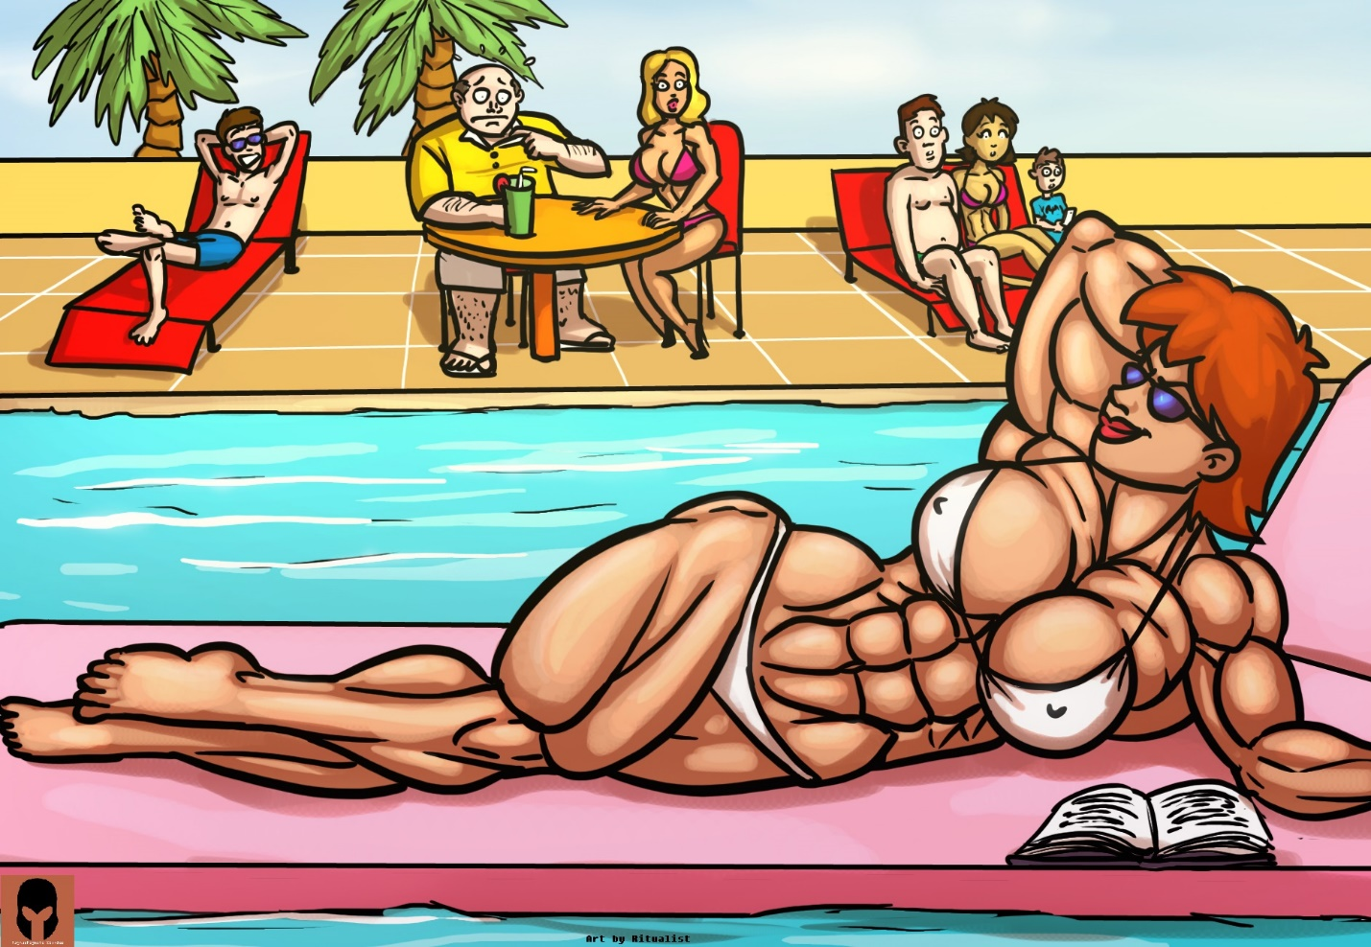

Eventually, Cory made his way over to his mother. “Hey mom,” he greeted her, “Think it would be helpful if I started cooking dinner? Should probably get started soon since there’s a lot of mouths to feed.”

“Sounds great dear!” Tara cheerfully replied. Part of her was surprised that Cory was willing to do such a thing without any preemption, but another part.

3.)

An hour later, Cory had finished cooking and called everyone in. The family gathered around to the feast he had prepared. They took turns piling food onto their plates, and met around the large dining room table. Not much was out of the ordinary, though Cory was surprised to see that Kiko had taken as much as Terry and Barry, which was considerably more than his own share. Of course, nobody could match Tara’s appetite. The amazon shoved mouthful after mouthful down her throat in a mechanical fashion, as if she were far more interest in the nutrients the food could provide than the taste of it.

“Wow Tara, you sure do pack that food away!” Estella observed.

“Well, you’ve gotta eat to grow.” Tara explained with a smile.

“Grow auntie grow! Just like you did at the pool!” Harry exclaimed.

“Oh, so you did notice, huh?” Tara replied.

Harry nodded vigorously. “Yeah, yeah! That was awesome! Can you do it again? Can you grow right now!?”

Tara considered his question for a moment. “I’m not so sure about that Harry. I need to push my body to its limits. Maybe later tonight I can, okay?”

Harry looked a little disappointed, but was mostly satisfied by the answer. More time passed, and eventually Estella spoke up: “You really cooked this Cory?” she asked.

“Oh, is there something wrong with it? I'm still learning...” Cory replied, nervous.

The blond quickly shook her head. “Not at all! It's quite delicious to be honest.”

Cory smiled, he was glad to hear that his efforts weren't wasted.

Tara spoke up next, “You're definitely getting pretty good at this!”

Next came Harry: “Yeah cousin Cory! You must be like a real chef! Good job, and keep powering up your cooking ability!”

Uncharacteristically, Kiko was next, “Yeah, not bad Cory. Would eat again.”

Feeling pressured from everyone else saying something, Barry spoke up, “Yeah, decent food.”

Finally, not wanting to remain silent while everyone else spoke, Terry finally added his thoughts: “Sure, yeah food's good. You've got talent kid. Hope ya don't keep wastin’ it on cookin' though.”

“Terry!” Estella yelled disapprovingly. Tara, Harry, and even Kiko shot him sour looks. Barry turned his gaze entirely away, staring directly at his food.

Terry threw his hands up into the air, “Just speakin' my peace. It's a free country kids.”

Estella wordlessly shook her head, and the subject wasn't approached again for the rest of dinner.

-

After dinner, Cory wordlessly gathered the plates and brought them to the sink, while the rest of the family idly chit-chatted. Soon the topic of what they should do next arose.

“Hey, I've got an idea!” Harry chirped loud enough to get the attention of everyone around him. After noticing he had a captive audience, he continued: “Let's see how strong aunt Tara is! Put those muscles to the test!”

As expected, Cory, Estella, and Tara were visibly interested in the idea, while Terry and Barry scowled, and Kiko remained apathetic.

“Sounds like fun Harry.” Tara replied. “Do you have anything in mind?”

“Hmmmm...” Harry thought out loud.

“Oooh, I know, how about you show us what you can lift!?” Estella spoke up.

Tara shrugged her brawny shoulders. “I can do that any time really, as long as there’s a gym around.” She turned her attention to Harry, “Say, do you have any ideas for ways to test out my strength?”

Harry pondered long and hard, his young mind thinking of the best way to really test his aunt. Eventually an ephiphany came to him. “Let’s do tug of war!”

“Tug of war?” Tara raised a brow.

“Yeah, yeah! You know, like two groups of people grab onto a rope and pull. The stronger side yanks the other down!” Harry explained.

“Ah, okay.” Tara knew fully well what a tug of war was, but she wanted to encourage Harry to express himself and his ideas. “Well, who would be on my team?”

Immediately Cory, Estella, and Harry all exclaimed they’d be on her team. Tara laughed warmly, but told them that probably wouldn’t be fair. This prompted another idea from Harry, “How about everyone versus you?!”

Eyes met one another around the table as the idea struck a unanimous chord. Tara was strong, sure; Tara was huge even — but could she really be stronger than all of them combined? She ran some mental math, and frankly wasn’t sure. In particular, Kiko and Estella were much more formidable looking than she initially imagined, plus Cory had been training a bit the past few weeks.

Cory spoke up, “Well, I don’t want to sabotage my mom. How about I play referee?”

“Aww, come on Cory!” Harry yelled out. “Don’t you wanna see how strong she is!?”

It was Cory’s turn to mentally maneuver through a small challenge: “Believe me, I already know how strong she is. Thing is, if there isn’t a referee, then the match can’t be official, you know? Best that I judge to make sure it’s by the books.”

Harry’s disposition changed immediately. To him, this tug of war was serious business, and Cory raised a valid point. “Oh, right, duh! How could I forget? Alright, you be the ref Cory!”

Barry and Terry exchanged sidelong glances at each other. They clearly weren’t up for this challenge, but it had gone too far for them to back out.

4.)
The two sides were readied. Tara stood across all of her extended family members. Cory was nearby, ready to referee the match.

“Say, how about we raise the stakes a bit?” Tara started, “Cory, how about you use your phone to record the whole match? We can put it on the internet. It'll be proof of my victory, or perhaps a reminder I shouldn't be arrogant.”

Cory shrugged. “If everyone is alright with that.”

Terry and Barry looked as nervous as ever, while Estella and Harry exclaimed that sounded like fun. That was enough consent for Cory, and he prepared his phone to capture the battle.

All of the combatants grabbed onto the rope. Terry, Estella, Barry, Harry and Kiko fumbled around for a bit as they tried to find the optimal position for their hands and feet. After some shuffling around, they were set. Tara on the other hand didn't require such setup, and as a result was ready to go from the start.

Cory preempted them with a count down, and on his mark, both sides began to pull. At first there was a complete standstill. Despite the combined efforts of Terry, Barry, Kiko, and Estella (Harry was, in actuality, just riding on Terry’s shoulders), Tara remained firm. The amazon pulled slightly, but also found that she couldn’t quite budge the collective mass of people pulling against her. This standstill continued for a while. Cory was somewhat nervous, as he thought that Tara would have won by now. It seemed that the battle would come down to matter of Tara’s stamina against their collective endurance.

“Come on Tara… you HAVE to win this. You can do it!” She quietly said to herself, summoning all of her strength. Something clicked within her, the intangible forces driving her to become as powerful as possible, to become a true ‘alpha female’ unlocked. Every fiber of Tara’s being shifted to meet this new goal, pulling into all available resources. The store of nutrition from her last meal sprang into action, and the amazon’s already immense body began to grow once again. She heard the sound of flesh tearing, her own, as the muscles in her body repaired themselves to new heights at breakneck speed.

The combatants on the other side of Tara’s rope were too focused on the task at hand to witness what was happening, but slowly, every muscle on Tara’s body was slightly expanding. “Yes… come on… come going body… keep getting stronger!” she said to herself again, finding that doing so seemingly provoked her body in compelling. It was a strange phenomenon, but Tara couldn’t afford the concentration to think about it. Another small growth spurt occurred, and one with keen observation would note that Tara actually grew half an inch taller as the rest of her body swelled up as well.

Feeling emboldened, Tara decided to play things up for the camera, “You recording this Cory?”

“Yup, want to make sure we’ve got a record!” the teen replied.

“Good, then make sure you get… THIS!” she yelled out, and with one huge motion put all of her strength into one explosive tug. Within a matter of moments, the collective group fell forward, and with another tug, Tara pulled them all to the ground before dropping the rope and flexing triumphantly.

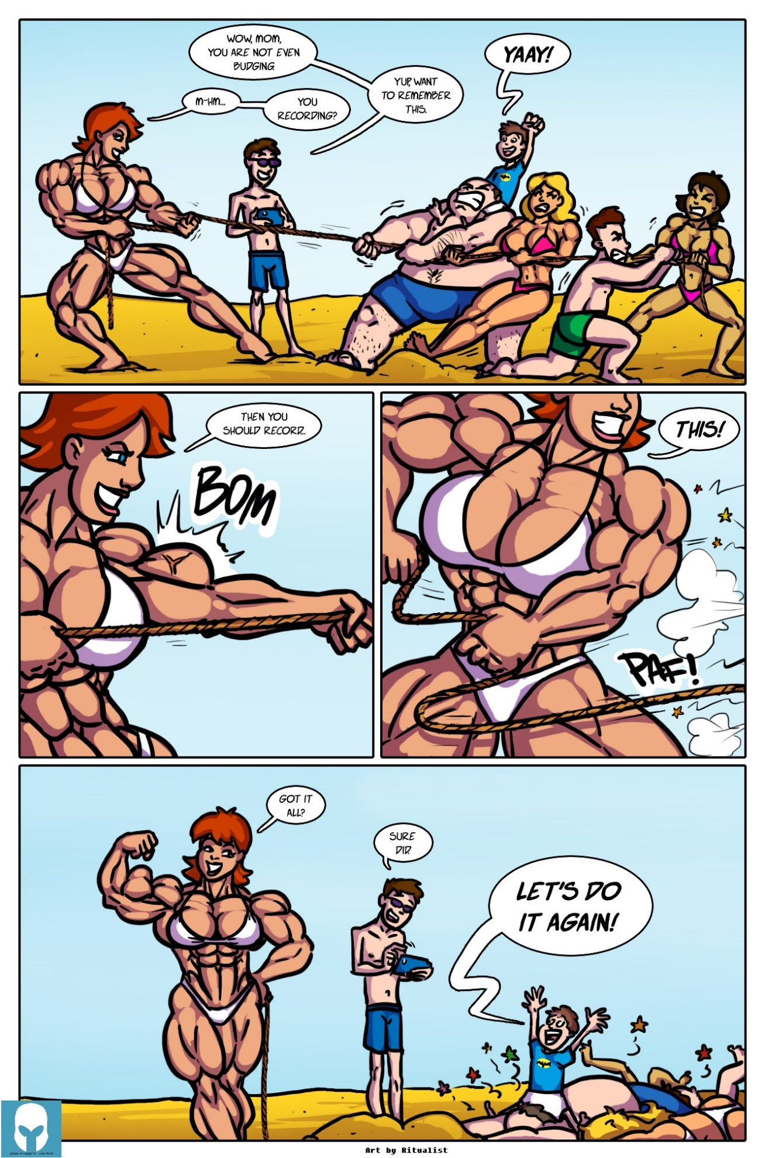

Seeing the opportunity for theatrics, she proudly boasted, “You know what they say, mother knows best!”

Barry and Kiko, despite being on the ground, let out a loud groan from the statement.

Cory helped everyone get up, and the crowd dispersed as they dusted themselves off.

“Aunt Tara is stronger than all of us combined!” Harry squealed, reveling in the idea of someone related to him being essentially superhuman. “I thought that mom and Kiko were strong for girls, but Tara makes them look like weaklings!” The words were delivered with a simple honesty and bluntness that only a 10 year old can properly deliver.

“Hey! What’s that supposed to mean!” Kiko yelled out.
“No arguments there!” Estella cheerfully responded.

Harry ran over to Tara, and grabbed onto her muscled torso. “You got even stronger back there, didn’t you auntie?” he yelled out with pure excitement.

Tara blinked a couple of times, “Yes, but how did you know?”

“I dunno.” Harry replied, “it’s just something that I can tell, you know what I mean.”

Tara laughed lightly. “No, I’m not so sure what you mean.”

“Anyway,” Harry continued, “You’re like one of those Jinsays from my favorite anime!”

“A what?”

“Oh, they’re uh…” Harry stalled for a moment, thinking of how to describe what he was thinking about, “They’re these like, people from space, who get stronger all the time. Whenever something challenges them, they just keep powering up! Like you!”

“Huh. Very interesting Harry.”

“I used to think that Kiko was one of them, but she’s like, scared of getting stronger or something. So I guess she might still be one, since some of them on the show don’t really power up much. Not you though! You’re just going to keep getting better and better, right auntie?”

Tara was taken aback by how openly warm and supportive the child was, especially considering his father. “Yes, I’ll certainly try my best to. Is that what you want Harry? For your aunt to become super strong?”

“Noooo!” Harry shouted. Tara was startled by this response, but the young boy quickly followed up: “I want you to become ULTRA strong. UBER strong! The strongest! Then to become even stronger!”

Tara laughed warmly again. “Well, I’m very glad to hear that Harry, but why do you feel this way?”

Harry shrugged. “I want my family to be the strongest ever! But I know that the guys can’t do it. Maybe they can get kind of strong, but… I know that the girls have the potential to always be stronger, so they should give it their all!”

Harry’s sudden spiel about strength triggered a train of thought in Tara’s mind. She began to wonder just what that much power would actually do for her. How useful would it truly be to become ‘the strongest, then even stronger’ as Harry would put it. Sure, her strength had been handy up until now, especially when those robbers broke in last week, but surely there would be a point of diminishing returns? As fun as it was to think about fanciful feats like lifting buildings overhead, what good would that much physical power really grant her?

Since this philosophy of continuously acquiring power seemed to be thoroughly ingrained into the young boy’s mind, Tara decided to seek the wisdom of youth on the topic, hoping for a fresh perspective: “Well Harry, can you answer a question for me?”

Harry nodded, “Of course!”

“After the girls become the strongest, what is the point of becoming even stronger? In the modern world, what is the use of that much power?”

Harry tilted his head to the side for a moment. Tara worried that her question was too complex, but after a short while, a familiar light returned to his eyes and he responded: “Well, the good guys need to make sure they’re stronger than the bad guys.” He explained.

Tara raise a brow. “Care to elaborate, big guy?”

“It’s like in that anime I watch. The good guys have to keep getting stronger to make sure they can stop the bad guys.”

Harry’s simplistic black and white view of things was refreshing. While Tara doubted that anyone would ever come close to surpassing her now, let alone after improving herself even further, it was fairly motivational to hear those words. Still, Tara wanted something more, a little extra justification for this path.

“Being able to beat up the bad guys is good and all Harry, but can you think of any other good reasons you think I should keep getting stronger?” Tara asked.

Harry thought for a few moments. It was immediately clear that a thought was forming in his mind, but he was having trouble putting it into precise words. Tara patiently waited, wondering what kind of mental gears were turning in the thoughts of someone so young. Eventually, the boy spoke: “You being so strong is good for everyone. I kind of wish my mom and Kiko would do that too. It’s like, you know, one of those role model things. You can change everyone around you just by being the best that you can.”

This was the thing that Tara had hoped to hear most. She was highly aware of the effects of her transformation on Cory, and hoped that they would ultimately be for the better. Hearing the young boy reaffirm this, knowing that the greater she became, the more she could inadvertently help those around her, inspired her even further.

“Thanks for the pep talk Harry. I’ll definitely make myself as strong as possible, not just for you, but for everyone - and hey, who knows, maybe your mom and sister will come around to our way of thinking?” she replied with a wink.

“Yeah, yeah!” Harry exclaimed, “Super aunt, super mom, and super sister! That would be awesome!”

“Now what in tarnation is goin’ on here.” Came the loud drawl of Terry’s voice.

“Oh hey dad!” Harry yelled out, “I was just talking to auntie about how she should become the strongest ever, then even stronger than that! Maybe we can get mom and Kiko to do that too!”

A chill crawled across the back of Terry’s neck. “Now where on earth are you gettin’ these ideas from, son?”

“Oh come on dad, you know I’ve always wanted Kiko to take her training seriously!”

Terry massaged the bridge of his nose gently. “Right. Anywho, how ‘bout you stop buggin’ yer aunt, and let me have a conversation with her? Run along and do somethin’ else.”

Harry nodded and agreed before scurrying off.

5.)
It was a long day of introductions, activities, flexing, and even growth. The guys were all tuckered out (though the women were secretly all still brimming with potential energy to burn), and the family decided to hang out for a couple hours before retiring for the night. They sat collected in the basement’s living room, facing the home entertainment theater. A random show was on television, and while Tara was personally opposed to the consumption of passive media ever since starting her transformation, she held her peace for now, allowing her extended family their creature comfort. They were, after all, the true owners of this house.

Tara was seated in the center of the main couch, her long, thick arms sprawled across the backs of four family members: to her right Estella was nestled snugly into her chest, while Terry sat uncomfortably next to his wife; to Tara’s left was Cory and Harry, who seemed generally unphased by Tara’s immense body. Kiko and Barry sat in separate seats disconnected from the couch.

As Tara sat with her family, she felt good. While Terry was legally still the top dog around, as he was the one who owned almost everything, everyone present knew otherwise. Tara’s overwhelming strength, beauty, and presence made it abundantly clear that she was, as her mind would put it: ‘The top alpha’.

Despite Terry and Barry’s uneasiness, the atmosphere was generally amiable. Everyone was happy, and there had been little to no in-fighting, which was quite rare for these family reunions. In the past, the air would be full of passive aggressiveness as Terry would underhandedly quarrel with both Tara and Estella; likewise, the children would needle one another with similarly puerile remarks. While there were still some remarks made quietly, generally by Barry in regards to Tara’s musculature being ‘too much’, things were going far smoother than ever before.

Tara’s mind was moving quickly. She was thinking about all of the possible things that could be done while the family was here. Ways to show off her strength, ways to grow a bit more right in front of their eyes, and ways to further try and shift their attitudes towards accepting strong women. She already thoroughly had Estella and Harry in her camp; that was an effortless feat.

Next would be Kiko, who was something of a wildcard. Tara could tell there was something unusual about the girl. Unbeknown to the young woman, Tara had been fully observing her during their time at the pool. Kiko’s body was too well-built, her reflexes and agility too swift. Either Kiko possessed an immense amount of untapped potential, or something else was going on. Tara knew the girl had been made to feel self-conscious due to both Barry and Terry’s comments, alongside societal pressures in general. If she could convince Kiko to let loose, to embrace herself, and to even build upon the impressive foundation present, Kiko would certainly make a formidable ally.

Then there was Terry. Terry was complicated and conflicted. Tara knew that Terry simultaneously wanted to push Tara to her full potential, but also didn’t want Tara to gain any more power. He was burdened with both a desire to follow scientific interest in seeing how far a human could develop, but didn’t want his ‘little’ sister, or any other woman for that matter, to wield that power.

Barry would be a the toughest nut to crack, and it was very well possible that swaying his mindset wouldn’t be possible in this visit alone. That said, if she could get Terry to change his tune, Barry would almost certainly follow suit. Tara concluded she would simply treat Barry with respect, deflect his insults, and act as a beacon of strength. There was no point focusing in on him until Terry was won over.

Through all of this, there was one more major factor to be considered: Tara’s mind. Her powerful brain that was constantly improving. This wasn’t made apparent to her guests, as there was little chance to showboat her intellect without coming across as condescending and annoying as her brother. That was where she’d defeat Terry. She’d find a way to push her brain further, eclipse Terry’s intellect, and prove total superiority over him. If she could do that, then undoubtedly both Terry and Barry would have to concede that men were not inherently better than women.

All Tara had to do was figure out just how she would go about doing this.

- To be continued! `

