Visited Upon the Father
Following the “Sins of the Son”
A Short Story
By Maryanne Peters

I carry my father’s name. I am Vernon Michaels Junior, just called “Junior” at home. Home was with my mother, as my father had been thrown out years before, and he was actually living in the town where I was going to college, and had a small place near the campus.

My father proudly called me “a chip off the old block”. He said that he got into a spot of trouble at college. He said that he would give the best advice – “Don’t get caught”.

Even when I did get caught, he said that it was nothing serious. He said: “I did worse”. He said that he would talk to the panel looking at my case. I should have told him not to. He just doesn’t understand that you can’t do this stuff anymore. This is the “Me Too” age.

Sure enough I was called before the Review Board. Because he lived so close Dad insisted on coming “to support me”, but he just made things worse. He made light of it. He said these girls should “count themselves lucky to have the attentions of my son”, or some such bullshit.

The sorority had come up with a fitting punishment - “Turnabout Term”. Maybe you have heard of it. If you want to stay enrolled then it is a semester on campus living as a girl – sorry, woman. Or is the case of a serious offence, a whole academic year.

The Chairman of the Panel railed against me about respect for women, but he said a special blast for my father. He said how appalling it was that an alumni like him would appear to be encouraging such behavior as mine. My father might complain that times have changed, and that in his day all frat boys did stuff like I had, but that was no going to help.

“We can only punish the student with two turnabout terms,” said the Chairman. “But we will just one semester if your father does it with you. We certainly think that he is equally responsible. It is just that with Vernon Senior the Dean will have to monitor his compliance too.”

To be honest, that sounded fair. I could do a semester, but the thought of spending a summer in skirts was just too much.”

“Okay, I will do it,” said my father. “How bad could it be. We’ll do it together. That should make it easier.”

Dad had his own financial services firm with others to do most of the work. It so happened that the Dean’s sister worked in his office, and she could confirm that my father would be turning up for work every day as “Veronica”. And the Dean said that he would be doing spot checks in the evenings, and maybe in the morning too. If he knocked on the door Vanessa had better answer or I was out of college, and that would be that.

For me, living and working on campus I had a thousand eyes on me. I had to be Vanessa 24/7 and there were no two ways about that either.

And the sorority claimed the victims right to give us the makeover from hell. That is what it seemed like with all the waxing and the plucking, and the shots that they said would ensure that our cocks wold not “misbehave” while tucked away to almost nothingness.

For our hair too, there would be no wigs that could be pulled off and cast aside after a day in drag. There were extensions that needed to be cared for and styled. A Minimum standard of presentation was required for anybody undergoing “Turnabout Term”, and that meant learning a whole new set of skills.

As for speech patterns and the behaviors that were incongruous, that was up to us, but basically I decided that it was easier just to try to fit it with our newly assigned gender than to stride about and growl in a baritone voice. Dad followed suit. At work it was simply easier to say that the boss was a away and leave his own office empty while he took a desk with the investment advice team.

The toughest thing for me was when my fraternity said that I would have to take a room in the co-ed hall because I was “Too female to remain at the frat house”. Some of these guys were in amongst what I had done, and I was not giving them away, yet still I got treated like that.

My pal Todd was more supportive. In fact he was more than supportive – he was right there beside me. The girls did not want to know me and the guys were not going to hang around with a male dressed as a female. But Todd suggested that we meet in the café to share notes and even met up for a drink and dinner off campus from time to time. It felt good to have at least one person.

For my father it seemed a little more difficult, but he did tell me that working in the general office put him in better touch with his employees.

He would send out emails as a circulate them to everybody including a new email address for Veronica, and then he would say things like “Did you read the latest thing we got from that dipshit we work for? I mean they all knew the whole story, but somehow Veronica became one of them and it was like old Vernon Michaels was on an extended break, tormenting them from afar.

It seemed to them that Veronica had the right to be treated as somebody different – somebody who could be judged by what she said and did, not by the person she had been.

Dad and I got together to talk about. Even when we went to his place we would find ourselves sitting down, not slouched on the sofa, talking about feelings and relationships like a pair of women.

My father had discovered that Vernon Michaels was not a nice person. I suppose that I discovered that the chip off that block, Vernon Michaels Junior, was not much better.

Veronica was invited out to drinks with the people from work, and that gave her more confidence outside of the workplace. She learned that she could pass as female, or rather that nobody would pick her out of the crowd from the office as being anything other than an attractive middle-aged woman.

But Veronica still did not seem to have a social life beyond that. Thanks to Todd at least I was able to get out some evenings.

So when the Dean came to check up on my father and Veronica came to the door while trying on some new clothes, she accepted the Dean’s invitation to dinner without much thought at all. She just needed to make an adjustment to her makeup as she had learned, and if that meant keeping the Dean waiting then that is just the way things are.

They went out together and as it was told to me the Dean was a perfect gentleman because Veronica as a properly behaved woman expected that of him. Or perhaps it was the way the Dean treated her that made her so “charming” and “feminine”. Whichever she was happy to take as compliments.

I think that I saw real change after that night too, and some other “dates” with the Dean that followed. As my father explained Veronica was so different at work too. As a woman she seemed to have acquired a better understanding of her clients. She was interacting directly as Vernon had done when starting out, but this time as more of a listener than a talker. She had the background and knew her stuff and was finding out that listeners sell product even better than talkers.

And then in my life, things started to get complicated with Todd. When we were out at some quiet spot of his choosing he told me that he was “starting to have feelings” for me. Of course, I told him that he was crazy and that he needed to remember that nothing about me was real except that I was a friend, and that he was my best friend. But maybe because of that fact, I liked the idea of him feeling the way he did.

I never should have let him kiss me but I did. We just seemed to be a boy and a girl in a moment, and that moment cried out for a little romance. But instead of that kiss settling it, it became an act of passion that drove us both a little crazy.

We should have known better, but by the time that he was inside me and I as scraming with joy as I took all he had, it was too late.

I told my father that when “Turnabout Term” was over I would probably not be going back.

Veronica looked at me a little disapprovingly and said that kids my age were far too free with their bodies. “You should expect a commitment from a young man before you lie down under him.” It sounded like something you would never hear out of my father’s mouth. He could not even commit to my mother. But as I said, we had both changed.

But maybe it was that insistence on commitment that lead to the Dean proposing marriage. Of course Veronica insisted that there should be a surgical procedure first. We have lined it up to do it together. Like a father son deal … or it that mother daughter?

The End

© Maryanne Peters 2019

Vanessa and Veronica

The original story was “Sins of the Son” inspired by another captioned image by Tiffany was from the father’s POV. My pal Annabelle Raven who just loves father-son-to-mother-daughter stories insisted an expanded version

Sins of the Son  Inspired by a Captioned Image  By Maryanne Peters  Sure, I played around in college, and did things just as bad as my son. I just never got caught. My advice to him was the same: Don’t get caught. My problem is that I said as much to the Review Board. It was not enough that my son had to suffer the stupid “Turnabout Term” punishment, to keep his place in the college I had to do the same.  The Chairman of the Panel railed against me about how appalling it was that an alumni like me would be encouraging such behavior in the “Me Too” age. That was never a thing when my fraternity was on the prowl. But times have changed.  I just wanted my son to have every chance. What father would not make the sacrifices required. If that meant a few months in drag, then I could do that. I run my own business. My son and me both – we could handle it. | 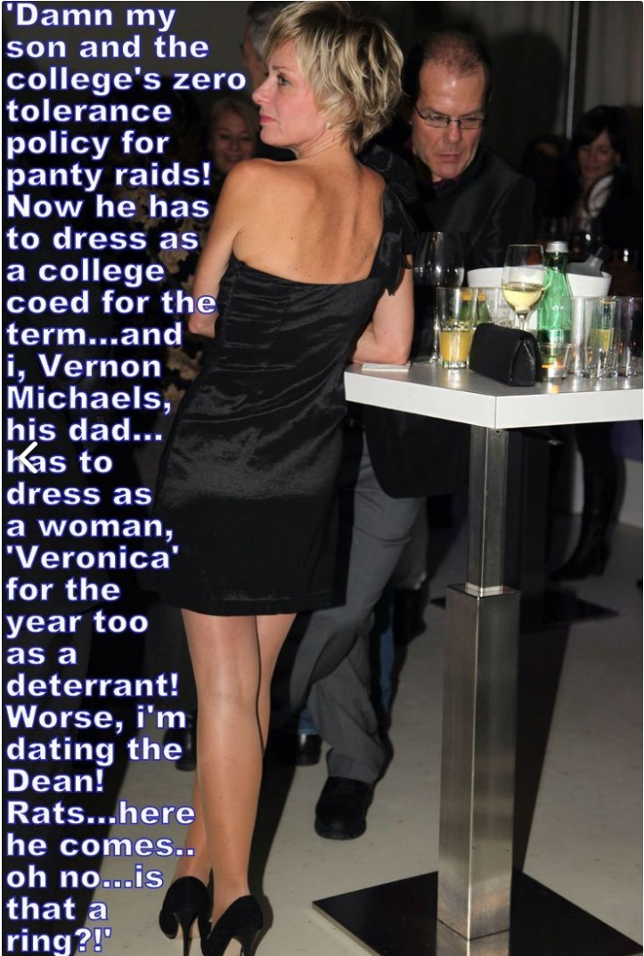

The Dean sat on the Panel too. He just stared at me. It made me feel a bit uneasy.

The sorority girls had two victims to work over and they seemed to relish it. I had the advantage of a good head of hair. All it required was a dye job and a cut, which within a few weeks with treatment, grew long enough to put in a few curls. The hard part was the full body wax and the facial and brow job which prevented me from fronting as a man anywhere.

The Dean said that while everybody on campus would ensure that my son met the requirements of “Turnabout Term”, he would need to pay special attention to seeing that I met the same code. That meant 24/7 dressing and presenting as a woman.

I had my son to watch my compliance at home. The kid said: “If I’m doing this Dad, so are you”. But elsewhere the Dean to it upon himself to keep me up to the mark. That meant dropping in on me at my office way too often and escorting me to evening engagements.

My employees should have burst out laughing when I turned up dressed as a woman for the first time, but they surprised me by being understanding. I still felt that I was the same person, but it seemed that they did not. They started to treat me differently, and I guess I responded.

Veronica is a better boss than Vernon Michaels. In fact, she is probably a better person all round.

My first evening business engagement as Veronica was awkward, but as I said the Dean insisted that he escort me. Somehow having him there, and having him scrupulously treat me as a woman, helped me to play the role. Clients called me “charming” and “feminine” which I could only take as compliments. And the Dean, being intelligent and engaging added to the occasion.

And somehow, I seemed to have acquired a better understanding of my clients. I guess that as Veronica I was more of a listener than a talker, although I have become much more confident in using my female voice since those first days.

We started going out just the two of us. I guess you have to say that we were dating. I was dating a guy. My son was too. And staying over at the boy’s place too.

I told the Dean that I was concerned about it. We had been out to a show and we had just dropped into a rather low class bar for a nightcap.

“This “Turnabout Term” is not good for him,” I explained. “He may never turn back.”

“If he doesn’t then maybe it has because he has always been a woman inside,” he said to me, as I checked my lipstick in my compact mirror. “Just wait there. I need to grab something from the car. I will be right back.”

There was another guy sharing the leaner. He had been staring at me, but he dropped his eyes as I looked his way. Guys do stare at me quite often. I guess that for a woman my age, I am pretty good-looking. Maybe if I grew my hair out a bit and wore it up? Or down in soft waves? I have legs that look great, especially in heels like the ones I was wearing. I could be perfect, if I had real breasts, and a cute little pussy between my legs.

Then I saw the Dean walking back towards me. My heart leapt a little. That really happens when you see somebody that you … that you … admire.

Oh my God. There is a little blue felt box in his hand, and a huge smile on his face!

The End

© Maryanne Peters 2019

